  CC Execs 2001-2002
  From The Rostra
  I can think of no better words with which to begin the year than these: we will come; we will see; we will conquer.
  2001-2002 promises to bring more victories at the Conference and Certamen, more fun and memorable moments with classics friends, more opportunities for Markham to continue with its record of excellence and exciting experiences for us all But to say all this makes on assumption, and it is one that I and the entire executive have already in good faith made: that you will be a part of it all.
  "Opportunities multiply as they are
  seized" observes The Art of War, which is exactly why I encourage you to involve yourself with--in fact, to immerse yourself in- Classics at Markham.
  Be at our meetings. Enjoy all our events. Do your best at our competition. Feel free to approach the executive with any and all ideas. Deride competing schools as vehemently, cruelly and frequently as possible. In short, please seize all opportunities that will present themselves to you over the next year--in return, I promise a million multiples.
  I'm told the motto for this year's Classics Conference is taken from the Aeneid and reads something to this effect: "mirabile dictu". It is on this message that I will close: For the classics student, there are
  Fall Certamen
  President
  Tom Carter
  Vice Presidents
  Nikhil Gandhi
  Brian Liu
  Treasurer
  Daniel Chiu
  Archivist
  Shirley Manh
  Newsletter Editor
  Peter Yu
  MDHS will be hosting the Fall Certamen again. It will be held on October 25th, 2001. Make sure you know what the topics are.
  Roman Life: Slavery; Games, Exercise and Baths; Travel and Correspondence; Roman Religion
  Mythology: Ch. 2, 5, 7
  History: first half
  Vocab Stages:
  Junior 1 - 4
  Intermediate: 13 - 16
  Senior 27 - 30
many wondrous things waiting to be seen. There is an entire world to explore.
Valete et bonam fortunam omnibus!

- Tom Carter, President of the CC

  Classics Web Links
http://classics.mit.edu/
The Internet Classics Archive contains a lot of classical literature.
http://www.capitolium.org/
The Imperial Forums website has pictures and text about ancient Rome, including a virtual tour of the Forum area.

 | CCn --- September 2001 --- http://scroll.to/theclassicsclub
NEWSLeTtER ? What, there's supposed to be news in this thing?
This is of course the beginning of the school year (as September usually is) and usually there isn't a lot of CC news (probably because no one was at school during the summer). But there are new members and they should be filled in on what we've been up in recent months.
In May 2001, we participated in the 33rd annual Ontario Classics Conference and did exceptionally well (would you expect less from MDHS?), with MDHS placing 2nd overall. This was only possible with the contribution of everyone involved. Let's continue this trend of improvement and get first this year (which would give us a one-year lease on the right to make fun of those Other SchoolsTM)!
We had a lot of fun, but we also learned a lot at the Conference (including but not limited to how to shout at the Other SchoolsTM in disdain). We're going to use our past experience to make this year's Conference even better. There's a short description of the Conference and its contests on our website, http://www.yrbe.edu.on.ca/~mdhs/classics/conf/. It's always good to get an early start on Conference preparation. For example, last year, we started one project in September and finished in May. Preparing early on will usually guarantee success (that's not a money-back guarantee, I'm quite broke actually).
In June, the CC had its end-of-year celebration. We had our executive elections just before playing games--in a proper, classical manner, as in trigon and Verba (think classical version of Bingo)--at the school, ending with a barbecue in the school courtyard. It was quite an interesting end to the year for all of us at the CC.
We're planning a movie night and a visit to some classically-themed performances in the near future, so stay sharp and look out for any CC announcements, you don't want to miss it. Together, we will bring in a new age of peace and prosperity (not that I'm trying to be Augustus). As Lucius Caelambulator would put it, vis sit tecum!

 | 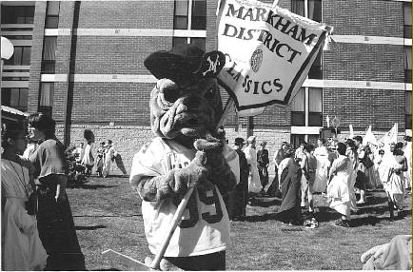
  Somehow, across distance and time, the MDHS mascot made it to the Classics Conference at Brock University in May 2001.
  That's our new standard, which members of the CC made last year. In the background, there are some students from Other SchoolsTM.
  This scene depicts the events from the pompa (the parade) at the end of the conference.

