
September 2002 http://scroll.to/theclassicsclub

 | What is Classics Club?  In theory, Classics Club was established several years ago to aid in providing MDHS students with a background in classical civilizations out of the classroom.  That aside, the goal of the club, in essence, is to do anything and everything fun in the name (or not) of classics. This includes, but will never be limited to, events ranging from movie nights to field trips, parties to sacrifices. You, however, are free to participate to whatever extent you like.  “What’s the point then?” you ask. What indeed. What’s the point of melon ballers? Exactly. | The club in truth exists as one of the largest student organizations in the school. It runs fun events and participates in interschool competitions – with incredible success, we might add – throughout the year. Come and experience it for yourself, beginning with our first movie night: Thursday September 29, after school, in the Pit. See you there!
  2002-2003 Execs
  President
  Nikhil Gandhi
  Vice President
  Chris Chien
  Treasurer
  Daniel Chiu
  Conference Chair
  Shirley Manh
  Archivist
  Theresa Chion
  Level I Rep
  TBA
  Level II Rep
  TBA
  Upcoming Events
  Movie Night – Sept. 19
  Oedipus Rex – Sept. 27
  Mcgaw Archaeology Dig – Oct. 29

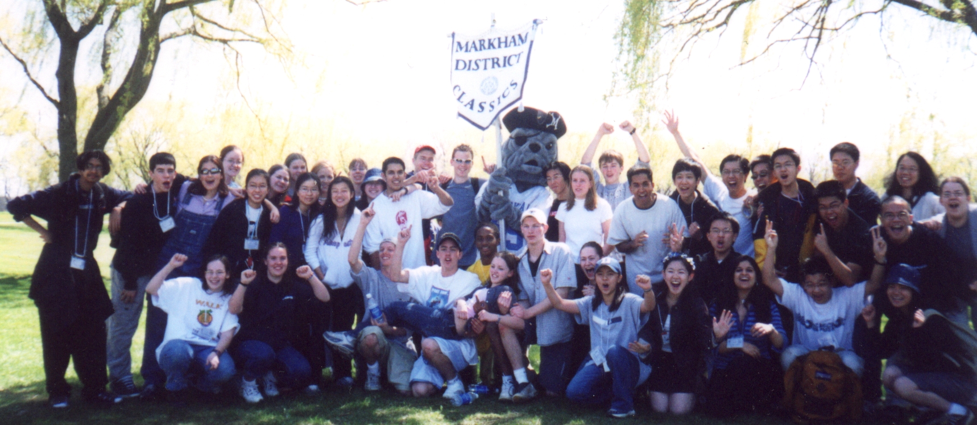 | Last year at the Classics Conference!

Del Presidente
By Nikhil Gandhi

Yes, I realize that title is not in Latin, BUT I did that to make a point! Clever me! I’ll take the long way around explaining it. Here goes…  I was climbing out of bed one morning in the back of Room Nine when I overheard the conversation of two classically unaffiliated students as they stood in the hall outside. From what I was able to derive, there were two guys. One was good. No, wait. He was bad. The first guy was bad, see? And that's important to remember. So this | guy, who was bad, he asks the other guy: “Are you joining the Classics Club?”  Wait, did I say the first guy was bad? I never remember this story. Now I think the first guy is supposed to be good. Change that. I'm not about to go back and re-type it, because I have sacrifices to conduct. But just remember, as you're reading, the first guy is good.  So the first guy, who is good, says, "I'm bad! He got us mixed up!" | "How do you know?" replies the bad guy.  "Trust me on this," says the good guy. "I'm bad. We have to start over."  "I don't think anyone is going to read this far, anyway," says the bad guy.  "That's what I'm talking about," says the good guy. "I would never say something like that; it's an attempt to clarify the situation. The fact that you just

did proves that you're the good guy."  "Look," says the bad guy. "We're never going to get anywhere in this story unless we just go with it, one way or another. Can't you pretend to be good?" | At that moment, a staff member walks by and collects their hats, figuratively derailing their respective trains of thought.  "Way to go," says the bad guy. | So anyways, I was deeply devastated that the second guy completely ignored the first’s question regarding his joining of the Classics Club, just because he wasn’t a Latin student. And so I decided to write the title in Spanish.

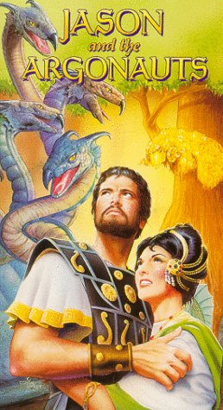 | How to Survive the Year in Classics  Shirley Manh  ✓ Keep Room 9 clean; it will be your second home  ✓ Come up with a cool nickname for Mr. McLaren (i.e.: Big Mac, Mac Daddy etc.)  ✓ Carry Gladiator around with you so you can watch it at any free moment (this means you'll need a TV and a VCR as well, unless you have a DVD in which case you'll need a DVD player)  ✓ Eat Mars bars a lot, they are the only Classically related treat  ✓ Keep your dictionary on you at all times, this way you can recognize derivatives in your peers' speech  ✓ Use ablative absolute clauses in every other sentence  ✓ Pronounce all your Vs as "wubbleyous", even when speaking in English  ✓ Do thumb-strengthening exercises (only the right one), and say "Beep!" simultaneously  ✓ Start despising UTS with all your heart  ✓ Remember that public schools are better than private schools  ✓ Learn how to fill out your name on a Scantron card  ✓ Figure out what "Quis es pater vobis?" means  ✓ Know that the answer to the above question is "Markham!"

On September 19th, come see Jason and the Argonauts on the Big Screen, in the Pit!

Salve Omnes!  It's good to be back at school isn't it, because it means a whole new year of classics to look forward to. I can feel the excitement in the air already as we begin to plan and discuss all the fun that we have in store for you. You'll be hearing more about various movie nights, classically related fieldtrips and much more. So until then, unite and take care of each other.  Positive Action Always,  Chris Chien  Vice President | 