Hydroplaning

Describes a situation when a tire is lifted clear of the runway due to fluid pressure beneath the tire. Such a condition happens mostly when the runway is wet, and occurs when fluid (water, slush) is not displaced at a rate fast enough from the tire/ground contact area (footprint). A melted area of tire can achieve the same effect, whether on a wet or dry runway (called “Reverted Rubber Hydroplaning”).

The result of the tire not being in touch with the runway is a total loss of braking ability. When hydroplaning occurs, the tire rides or skids on a wedge or film of fluid over all or part of it’s footprint area. This wedge is the residual surface fluid that has not been removed by the tire from the footprint area. As speed increases the wedge moves further back on the footprint area, until at “Full Hydroplaning Speed” it has lifted the tire clear of the runway surface. At lesser speeds there may be “Partial Dynamic Hydroplaning”.

Water, and contaminated water has extremely low friction capability, and so a tire riding on a film of water has little or no braking friction at all.

The build up of fluid pressure beneath a tire depends on:
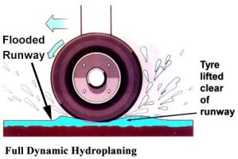
- tire pressure
- fluid layer thickness
- fluid density and viscosity
- runway texture
- tire tread pattern and depth
- groundspeed

Dynamic hydroplaning
Really, this can be split into two sub-types, namely Partial Dynamic Hydroplaning, and Full Dynamic Hydroplaning.
Partial dynamic hydroplaning occurs regularly when operating on contaminated runways, and the antiskid system does a very good job of limiting it’s effect on braking. This is where part of the tire is lifted off the runway due to the effect of the fluid wedge. It can occur to a grooved treaded tire at water depths of about 2mm or more.
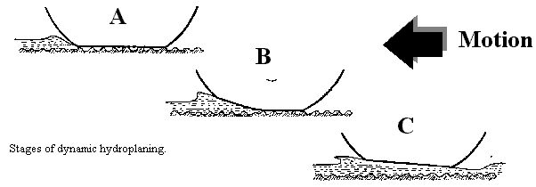
The above diagram shows three wheels at various groundspeeds on the same flooded runway.
At “A” the aircraft is moving forward slowly, and the entire footprint is in contact with the pavement. The tire is managing to “pump” enough water off the runway as the wall of water built up at the front is small.
At “B” the aircraft is moving at such a speed that the wall of water ahead of the tire cannot be entirely pumped off the runway surface, and a wedge of water is lifting part of the tire clear of the runway. This is partial dynamic hydroplaning.
At “C” the aircraft has accelerated to it’s full dynamic hydroplaning speed, as witnessed by the entire tire being lifted off the runway. This means, in the case of the AB6, the entire 370, 000 lb weight of the aircraft at takeoff is being supported on a film of water only a few millimeters thick.
Dynamic hydroplaning (con’t)
The major factor involved in determining the hydroplaning speed of a tire is it’s tire pressure.
There are other factors, which due to their variability are hard to quantify. They are:
- Tire wear (ie: tread depth)
- Runway surface texture, and whether the runway surface is grooved.
- Contaminants on the runway such as rubber deposits and runway markings.
For theoretical calculation purposes these can be ignored when finding full hydroplaning speeds.
The full dynamic hydroplaning speed for a tire depends on whether it is rotating, and therefore able to pump water off the runway surface, or is not rotating (not able to pump water off the runway).
Remember that tires may be considered as pumps, and a pump that is not turning cannot move any fluid.
These formula gives the theoretical minimum speed in knots required to lift the entire tire up off the runway.
Notice that this locked wheel formula gives a lower speed than for a rotating wheel.

Formula for stationary (locked) wheel landing on a contaminated runway

In effect the speed formula for a non-rotating wheel relates to a locked wheel during a rejected take-off or a wheel landing, in both cases while on a contaminated runway.
Minimum speed for full dynamic hydroplaning is 7.7 x √tire pressure (PSI) - Locked Wheel
The AB6 main tires have a pressure of 200 PSI.
The minimum full dynamic hydroplaning speed of the AB6 is around 109 kt (locked wheel).
Therefore, a landing onto a contaminated runways, until the wheels “spin-up”, the mains are likely to hydroplane. Below this speed there may be partial hydroplaning, but the antiskid system will normally handle any loss of traction well.

Rotating wheel formula on a contaminated runway

The rotating wheel formula is for a tire rotating during the takeoff phase, or after the wheel has “spun-up” after landing.
Minimum full dynamic hydroplaning speed is 9 x √Tire pressure (PSI) - Rotating Wheel
The minimum full dynamic hydroplaning speed of the AB6 is around 127 kt (Rotating Wheel).
Therefore, when our decision speed is above this speed, we are likely to hydroplane during the initial phase of a rejected take-off. Furthermore, partial dynamic hydroplaning may continue to speeds well below the full dynamic hydroplaning speed above.

Viscous Hydroplaning
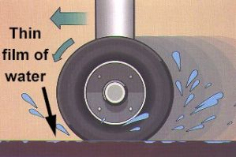
This usually occurs on very smooth runway surfaces, with as little as 0.025 mm of water.
Major danger areas are on the white runway markings such as the piano keys, and the 500 ft and 1000 ft touchdown markings. Also of danger is the runway touchdown zone, about 1000 to 1500 ft past the threshold where most aircraft land. This area becomes contaminated with burnt-on rubber deposits, which have the affect of smoothing out the runway surface by filling in the minute gaps between the grit.
These areas of rubber build-up are supposed to be cleaned off by airport operators, but don’t count on it.
Viscous hydroplaning is often associated with contaminated runway surfaces, not just wet ones. Probably the worst scenario for creating a viscous hydroplaning event is when contaminants build up on the runway surface over a long dry spell of weather, followed by a dew, or very light rain. An aircraft touching down on a part of the damp runway that is contaminated with rubber deposits may experience the same degree of traction as it would if landing on an ice covered runway. Rubber, landing on rubber with a little bit of water between them make a slippery and dangerous sandwich combination.
There is no set formula for calculating viscous hydroplaning, but bear in mind it can persist down to normal taxi speeds.
The runway contaminant could be ice, for which the minimum speed for hydroplaning is anything faster than a complete stop.

Wet snow (slush) is often encountered on runways in Europe and North America. Slush has a much higher viscosity than that of water, therefore viscous hydroplaning can occur on slush covered runways to much lower speeds than for water covered runways.

A runway that is contaminated with rubber deposits, oil, or mud, in addition to being wet is very likely to cause viscous hydroplaning.

Reverted rubber hydroplaning
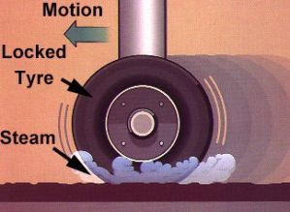
This occurs when a wheel becomes locked up, and can occur on very slippery or icy runways. It can occur at any speed, and may persist until the aircraft comes to a stop. It normally follows after either viscous or dynamic hydroplaning. With the wheel locked up, high temperatures are formed which result in the tire rubber reverting to it’s natural latex state. This leads to loss of tire tread, flat spots on tires, and filling of tire tread with molten rubber. It also can cause tire blowouts and tire fires.
During reverted rubber hydroplaning, the molten rubber forms the slippery surface for the tire to ride up on.
On water contaminated runways, the friction of the locked wheel can cause steam to develop at the tire footprint. This steam assists further in lifting the tire off the runway and melting the rubber.
There is no speed formula for reverted rubber hydroplaning.
Tire Cornering Force
An important function of tire/ground friction is to produce cornering forces.
Tire cornering forces are the primary means of controlling runway tracking on the ground-even on very slippery runways.
On slippery runways a tire develops its maximum cornering force at about 5 degrees of yaw; beyond this point the side force decreases rapidly. A high vertical load (i.e.: weight on the tires) and no tire skidding also increase the cornering force available
Whereas a certain amount of tire rotational slip is necessary to produce a braking force, that same slip reduces the tire cornering force.

Braking and skidding, reduce tire cornering force. A locked tire produces no cornering force at all, so spinning up all the tires as they touchdown is essential to maintain runway tracking capability.

As the pilot you can NOT change the available friction on the runway, but you can increase the vertical load on the tires by lowering the nose, which will reduce lift. Promptly lowering the nosewheel onto the runway will also greatly increase the patch area available for cornering, and will assist in keeping the aircraft straight.

If a side slide should develop, release the brakes momentarily. This will increase the cornering force of the tires and get the aircraft straightened up quickly. Do NOT stay on the brakes ! Side slides can occur when there is significant cross winds. These not only blow the aircraft onto the downwind side of the runway, but also weathercock the aircraft so that the nose swings into wind (i.e.: pointing back toward the runway center).

Improving runway surface
- Some runways have a very noticeable camber. This allows any water present to flow off the runway. Roads also have a marked camber (ie: rise up from gutter to the centerline), for this purpose.
- Some runways are porous, and/or have grooves running across them. Both features assist in clearing water off the runway, and the grooves also help in keeping the tire rotating.
Summary
- Smooth, flat runways with poor drainage, rubber deposits and painted surface markings are the worst.
- Runways that are porous, grooved and have a marked crest toward the centerline are best.
- Lower the nosewheel as soon as possible after the main wheels touch down.
- Use thrust reverse if available. Spoilers and reverse thrust together contribute about 70% of the total braking action during the high speed portion of the landing roll on a slippery runway. They are less effective at low speed, where wheel braking effort has a greater contribution to total deceleration.
- Ensure the speed is safe before turning off the runway.
- Remember that greatest tire cornering effort occurs when braking is NOT used.
- Tire condition is important. Carefully inspect the tires for tread depth, cuts and flat spots.

