 CALGARY CANADA-CHINA FRIENDSHIP ASSOCIATION
AND SHOU LA SHOU PROGRAM
______________________________________________________________________________________________
Newsletter OCTOBER 2013
_____________________________________________________________________________________________________________________
For further information, see our federation website: www.fccfa.ca/Calgary.
Newsletters are available at dinner meetings and via email (text only) and on the web site (with photos.)
2013 Year of the Snake
Snake people were born in 1917, 1929, 1941, 1953, 1965, 1977, 1989, 2001



Design: Anna MacLellan

RESTAURANT VENUE UPDATE
After enjoying many years of holding regular dinner at the Regency Palace, the executive decided to try some different venues, which we hope participations have enjoyed. We are always looking for the perfect combination of convenience, parking, good food, and price match for our group. Thanks to Donna for organizing all our dinners and to other members for recent suggestions for alternatives.

DINNER PAYMENT POLICY
We have been experiencing difficulty with bookings, no shows and payment requirements. As a not for profit organization we try to use our resources wisely. We are all volunteers and it tak) We do not have the flexibility to confirm then pay for dinner for no-shows.
If you plans change please let us know so that we do not have to delay dinner waiting for registered attendees who are possibly just delayed. While we realize that last-minute problems arise, we must in future ask that once confirmed on the cutoff date, members honour the payment if required.
This year we tried arranging payment in advance for one ShouLaShou event, which was subsequently cancelled for lack of registrations. The restaurant was to open on Sunday afternoon especially for us and we have to give plenty of notice for cancellation. Fortunately there was no financial loss.
Later we also cancelled a regular CCCFA dinner, also for lack of registrations. Donna often receives confirmations after the deadline and then often people just simply do not appear at the dinner. In the past, the restaurant has been very accommodating and Ted has used his best negotiating skills to try to make sure the payment required has matched the proceeds collected from members. Unfortunately we are not always able to do this.

SHOU LA SHOU EVENT EARLY DECEMBER
Join VP and ShouLaShou Director Morag MacLellan and all the family members of Shou La Shou for another fun-packed event. Notice to follow soon.

CCCFA DINNER DECEMBER 9
Join us Monday December 9 for a special festive season Show & Tell dinner, location to be advised. We ask that everyone please bring along an object to share with other members at your table. This item should be meaningful to you in some way in relation to your personal link to China. Book your place early!

MEMBERSHIP FEE DUE FOR 2014
Please note membership dues are also due for the upcoming year. For those not in attendance at the December dinner, please send membership renewals to Treasurer Ted Foster at 159 Oakmount Road SW, Calgary AB T2V 4X3 in the amount of $15 for members and $25 for families.

OCTOBER DINNER: AGM NOTES
A sumptuous 13 course dinner was held at this new venue, TaiPan restaurant. Thanks to Angela Chu for working with Donna to arrange this. A small private room and easy parking were plusses.
Sheila thanked all the executive members for allowing their names to stand for re-election (see list below) and for the work they have all put in over the past year on behalf of us all. Reports were presented by President, Treasurer and ShouLaShou Director. Many good ideas emerged from the round-table discussion.
After many years servicing in various capacities, Hei-Ling Choi stepped down from the executive to remain a regular member. We thank her for all her hard work over the years in Canada and in China on our behalf.
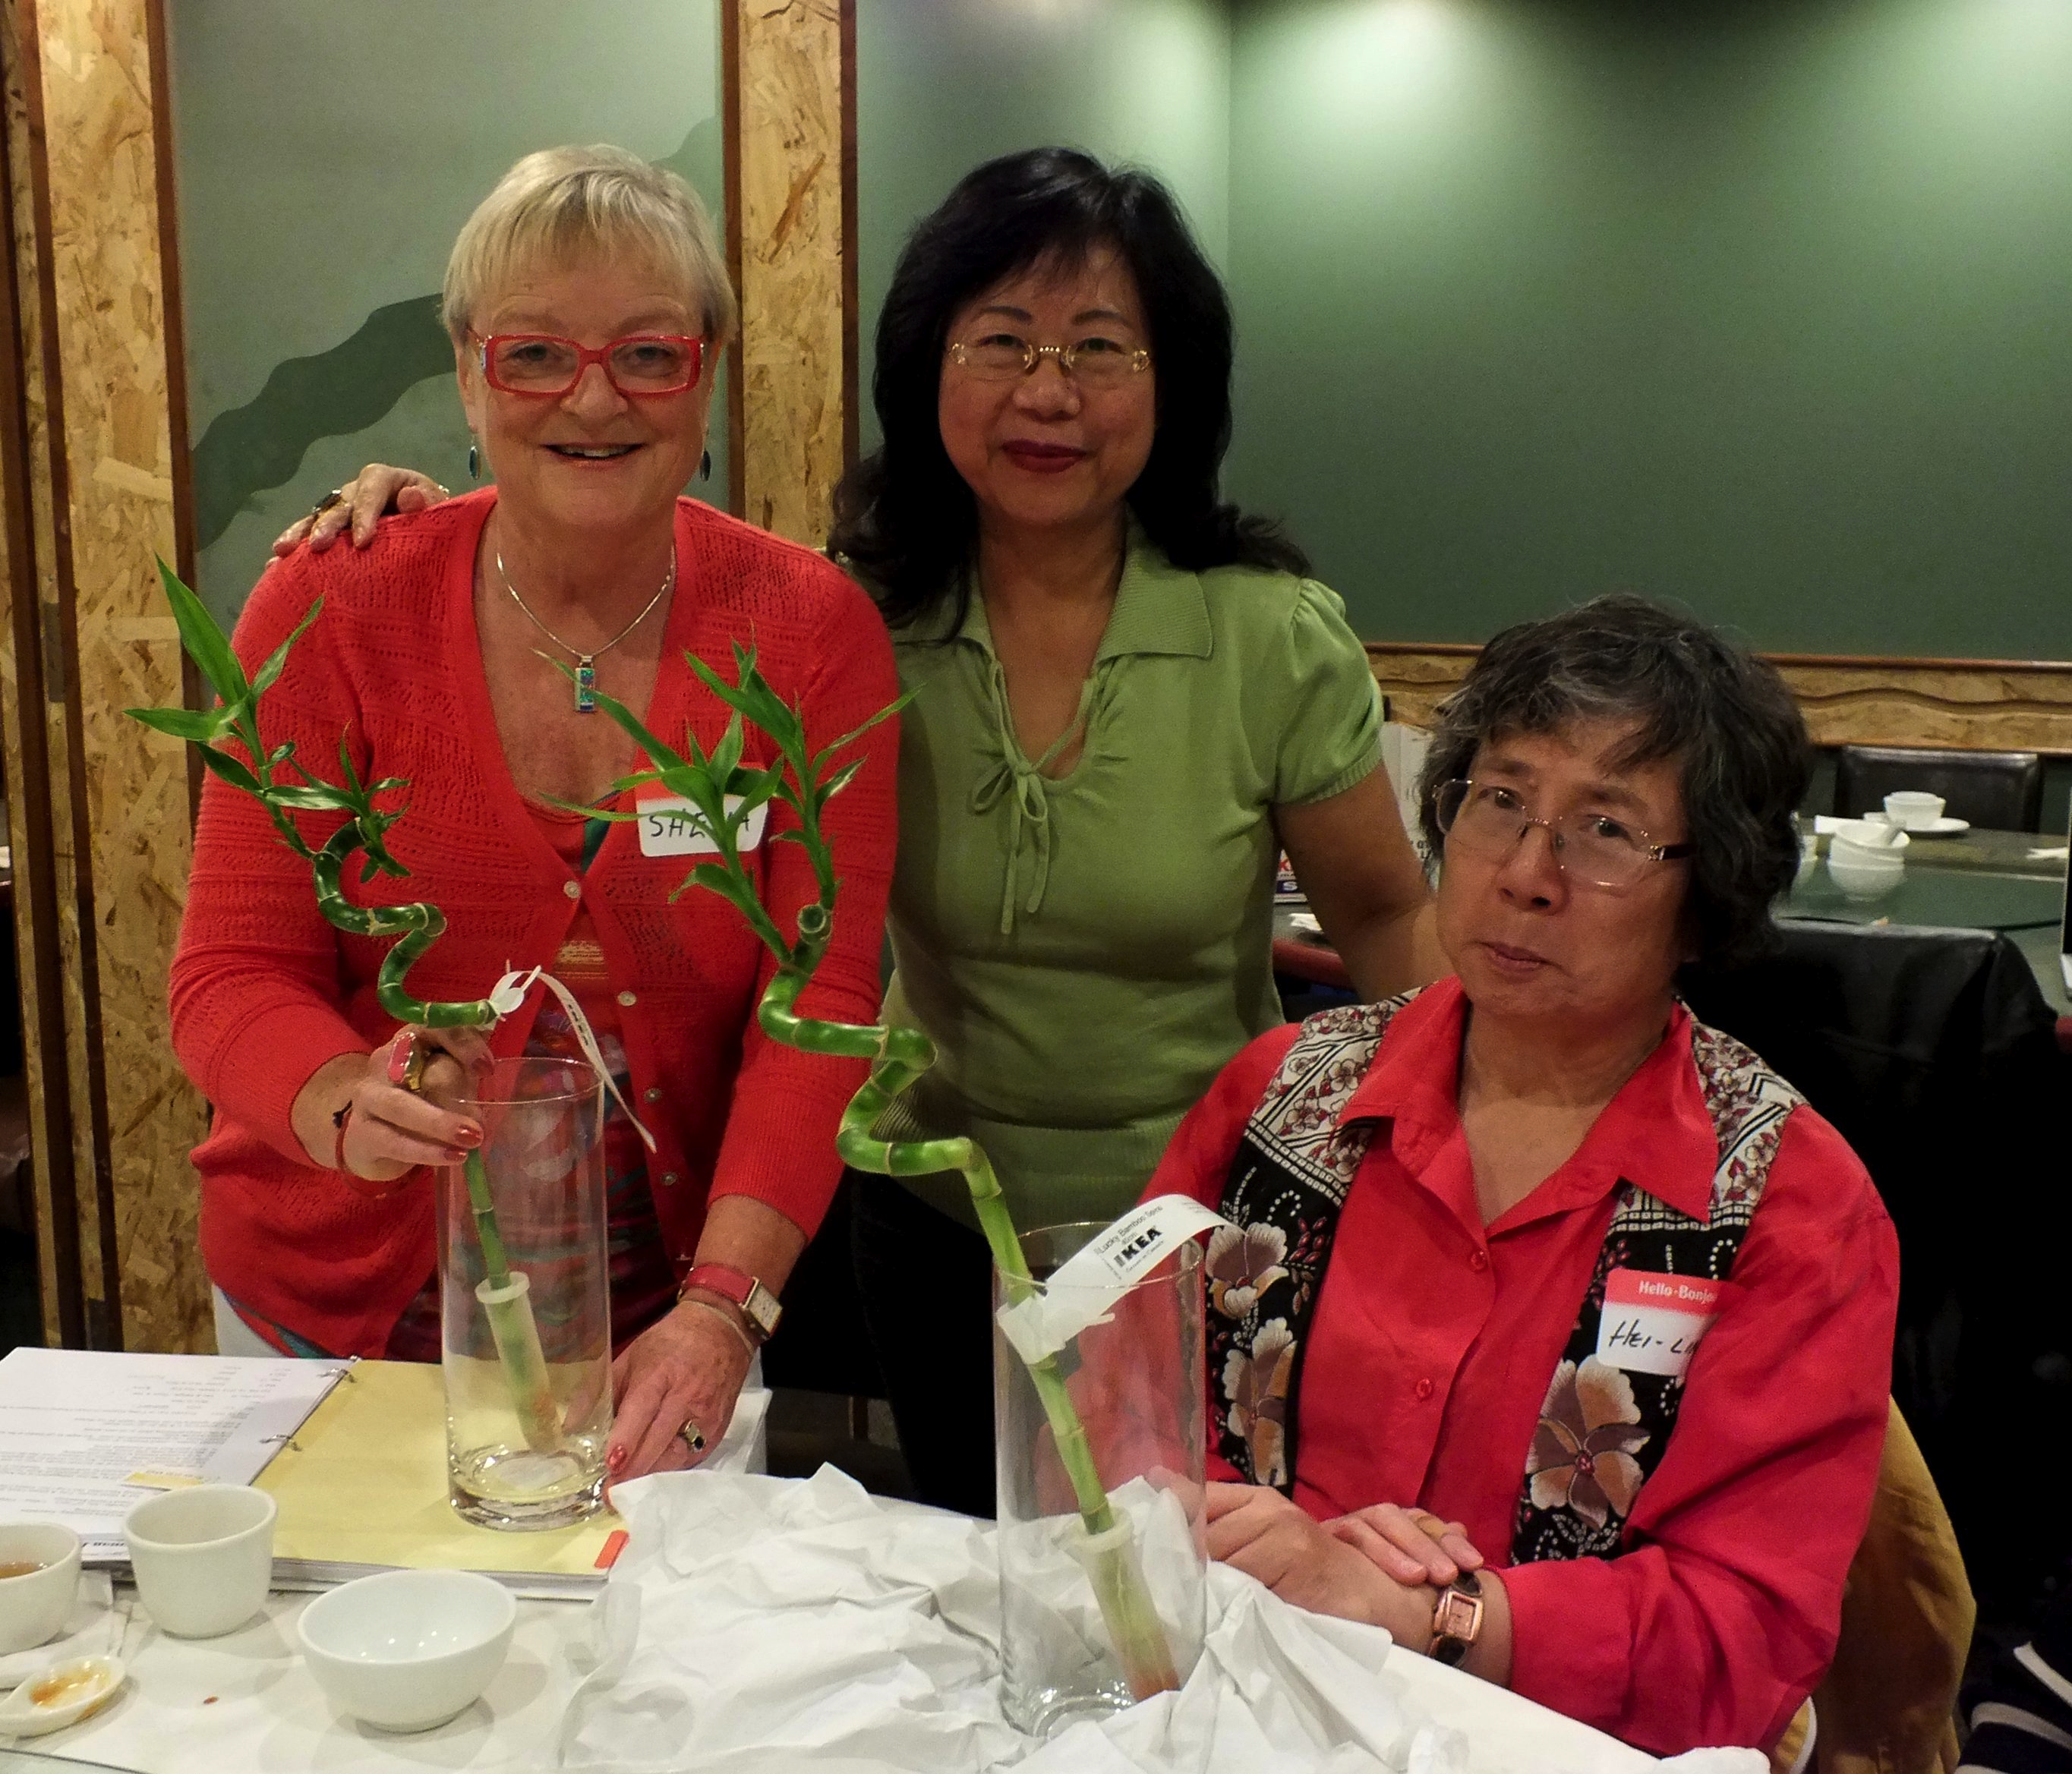

Draw prizewinners Sheila Foster and Hei-Ling Choi, with Kelly Wan
(photo Len Chan)
SHOU LA SHOU
China Heritage Tour for ShouLaShou families
Last year Morag and Joanna arranged a trip to China for families with adopted children age 10+ Families would only pay air fare to China, Chinese hosts paying their 9-day tour costs.
Unfortunately, we did not have sufficient response to send anyone, as most of our participant children were under age 10. We now have some interested families for the 2014 Heritage Tour. We will examine ways to encourage participation from Calgary families.

Summer 2014 SLS Summer Camp
We still hope to arrange a summer camp in Calgary for the SLS children.

CONSULAR NEWS
Fosters hosted Consul General Liu Yongfeng , Deputy Consul General Wang and Vice Consul Jia at their home in June. Mme. Liu will leave Calgary in November to take up her new consular position elsewhere. Deputy Consul Wang returns to Beijing.

FEDERATION NEWS
Check the federation web site for regular updates for all chapters. Our web site, sadly out of date, will be updated soon.

Cross-Canada Travels
On a recent RV trip across Canada, Sheila and Ted Foster visited many friends and relatives and renewed acquaintances with some Federation friends, including past Federation presidents. Among them were a lunch in Winnipeg with Fred Drewe and three of his executive, and later a dinner with Fred on their return trip; in Ottawa a lunch with past president & vice president Lolan Merklinger and Gilliane Lapointe. In Toronto a dimsum lunch and a Shaw play in Niagara on the Lake with past president (now Toronto president again) Michael Copeland; in the Muskokas a 2-day stay with retired Toronto president Sandra Whittall. It brought back many good memories of shared experiences in China and Canada.

FCCFA AGM OCT 27: Sheila Foster and Morag McLellan will represent Calgary at the upcoming October 27 AGM.

PRESIDENTS FORUM followed by FCCFA Board meeting
Sheila and Ted Foster hosted a 2-day forum for federation discussions at their home in April. Attending were presidents from Victoria, Vancouver, Calgary, Winnipeg and Toronto. Ottawa chapter declined to participate and put forth a motion to stop paying federation membership fees. A moratorium on fees was agreed for two years for all chapters. Federation membership is declining and we seek a meaningful new direction to serve our purpose.

DINNER AND SHOU LA SHOU EVENTS PLANNED FOR 2013/14 (Note changes)
Dinners: 2013: Dec 9; 2014: Feb 17, May 12, Sep 8, Dec 1
ShouLa Shou events proposed 2013: Dec 3, 4 or 5; 2014: March 9 and November
We host consular representatives and guest speakers to our dinners.

INTRODUCTION TO MAH JONG
Some members are still interested in learning this fun game. Ted took up learning the game on our Snowbird trip south last winter! Let us know if you wish to join the group.

2013/14 Executive Committee Members
President & Newsletter Editor– Sheila Foster 251-6369
VP & Shou La Shou Director – Morag MacLellan 240-1825
Treasurer – Ted Foster 251-6369
Secretary – Kelly Wan 235-4956
Social Director – Donna Lamb 283-3368
Director at large – Tony Lamb 283-3368
Director at large – Joanna Chang 650-3420

