ISSN 1911-687X December 2007



FCCFA Newsletter

Federation of Canada-China Friendship Associations

Honourary
Membership
in the
Federation
of Canada-China
Friendship Associations.

Fleming McConnell
MD FRCPC

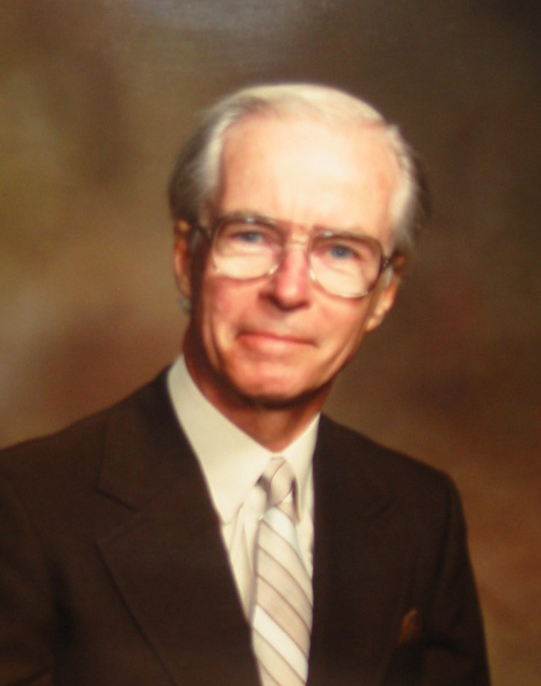

Dr Fleming McConnell is a retired radiologist, living near Victoria, BC. He was born in Manitoba, grew up in Saskatchewan, Alberta and British Columbia. He served with the Canadian Forces at the end of the Second World War in Canada and Europe. He studied at University of British Columbia, received his MD from University of Toronto, did a Radiological Residency Program at Harvard, and the Massachusetts General Hospital. He is a Fellow of the Canadian College of Physicians and Surgeons. He was on staff at the Montreal General Hospital, the University of Alberta Hospital, and the Wetaskiwin General Hospital, from which he retired in 1989. He and his wife, Dr. Aileen McConnell moved to Vancouver Island in 1990. They live on a sheep farm near Victoria.

Fleming’s passionate interest in China evolved from a glimpse of The People’s Republic of China, seen beyond a carefully guarded border post between Hong Kong and PRC. At that time he spoke of how little he knew of that vast country beyond… and then set about discovering its history, geography and people in his own inimitable and relentless style. Living at that time in Edmonton, Alberta, he began to plan to visit and travel in China, but preceded those plans by starting Mandarin lessons. He, along with his wife Aileen, had always felt that they did not like to be in a country and unable to speak the local language. Informal lessons were followed by Mandarin 101 at the University of Alberta, and this was tested on a first visit to Beijing, Xian, Hangzhou and Shanghai. At that time, thanks to Premier Lougheed’s strong commitment to increasing Pacific Rim contacts and relations, Alberta was enjoying many educational and cultural exchanges with Heilongjang Province. Harbin and Edmonton as Legislative capitals were actively ‘twinned’, while Daqing and Calgary as the Oil Cities had their own relationships. School sports teams traveled eastwards and westwards, Edmonton had a winter Ice Palace and Ice sculpture competition, business and mayoral delegations crossed the Pacific, and there was for years a large number of post graduate students from several Harbin Colleges and Universities studying at the University of Alberta. The Chinese Students’ Family Christmas Party was one of the social highlights of the year. There were also Medical Faculty exchanges. Fleming and Aileen were quite heavily involved in most of these endeavours. Aileen was Program Chair of the Edmonton Harbin Association for some 10 years.

More visits to China followed. The McConnells were part of the first Canadian group to take a cycling holiday in China, and joined a McGill University credit course in Mandarin spending half a term at Zhejiang University in Hangzhou and the second half at Nanjing University, living in student residences. This was almost total immersion! During those years the Farm south of Edmonton welcomed many visitors from China.

There were visiting business delegations, one or two members of which rode horses, while two eminent artists, husband and wife, stayed and painted for several months, revelling in the brilliant winter prairie light. They were later to own and run the very successful Yang Yun and Li Mo Art School in Vancouver.

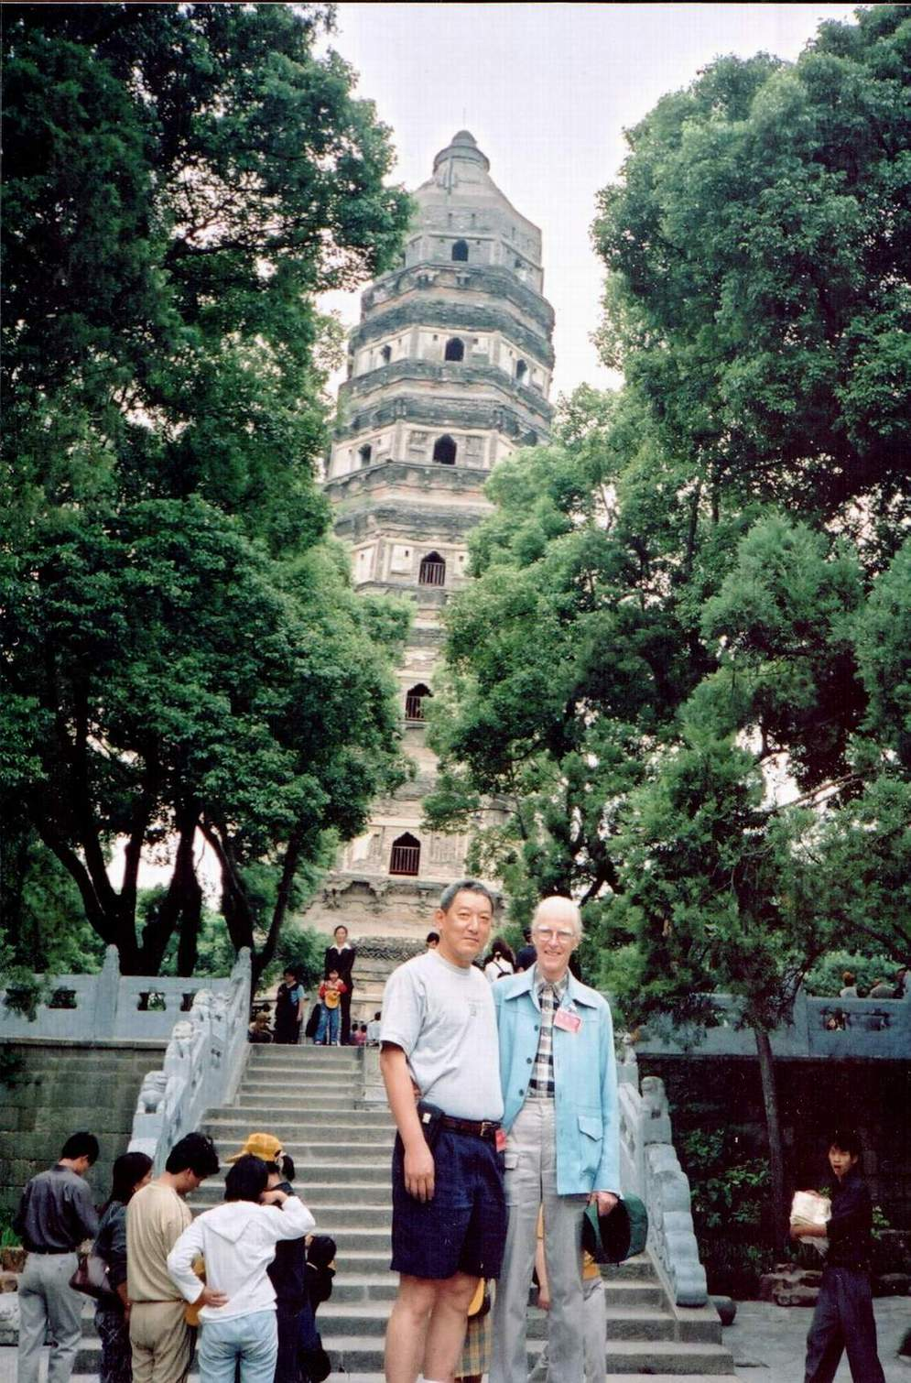

Tiger Hill Park, Suzhou

A Bank of China Human Resource Official from Beijing was there during the Tiananmen Square episode and a physician from Harbin came to discuss Chinese and Western medicine programs.

In 1990 Fleming retired from his position as a Radiologist in Alberta, Aileen left her beloved stable and horses (and medical positions), and they moved to Victoria. They were soon to become involved in the Victoria Canada Friendship Association, Fleming later becoming President, and serving in different executive positions. However another connection with China was developing.

The McConnells were living near The Lester B. Pearson College of the Pacific, and soon discovered that the 200 strong student body with representation from 76 countries, did not include any students from China. At that time it was not an accepted policy for high school students in China to study abroad. Fleming felt very strongly that the United World College vision of having young people live together, study together and learn of each others’ cultures, religions, national concerns, similarities and differences, could only lead to a better understanding, and acceptance of those differences as well as an informed appreciation of each other’s history. He set about having high school students from China introduced to Pearson College.

In Vancouver he and Aileen found an ally in the Chinese Consul General whom they invited to visit Pearson College. Once on the College campus, seeing what was happening among those 200 international students, the Consul General needed little convincing that there should be students from China in that group. With his help and using the already present Sister City connection between Victoria and Suzhou, discussions began with the 2 most prestigious high schools in Suzhou. It was eventually agreed that each year, 1 student would be chosen from a selected group of top students at both schools, with the idea that the chosen candidate would alternate between the 2 schools. As all students at Pearson College attend on full scholarship (there are no fee-paying students) the McConnells decided to fund the scholarship for the students from Suzhou. The first student arrived in September 1992. And the rest is history. Over the years, as Pearson College increased its ‘College of the Pacific’ profile, more students came from other Asian countries; Suzhou sent two students each year for several years. Aileen and Fleming’s home became the Chinese home from home, not only for the students but also for visiting parents. After their 2 years at Pearson almost all the students return regularly from wherever they may still be studying to Nearaway Farm, where they learned many things beyond the IB curriculum.

All this while Fleming was continuing to visit and travel in China, serving in various ways to increase Canada China relationships , hosting delegations, mentoring Chinese students, setting up displays at Sister City Days at Victoria City Hall, and generally maintaining his ever widening circle of connections with China. He and Aileen have returned several times to the Schools in Suzhou on special anniversary occasions and to visit with the large group of student Parents now linked to Victoria. Each has been there for the student selection process on various occasions. As a continuing member of the Victoria Canada China Friendship Association Fleming is still serving on the executive, and tries to have some Chinese students from Pearson College attend various Association social events. His extensive library of books by Chinese authors, about China, its history both past and present, keeps him up to date with current affairs in China, and his regularly maintained telephone and e-mail contacts with former students serve to keep those cherished friendships in excellent repair. For Fleming, Canada China Friendship is a very real and ever present part of his life.

Honorary Membership
in the
Federation of Canada-China Friendship Associations.

Aileen P. McConnell MB DRCOG FRCPC

Dr. Aileen McConnell was born in Belfast, Northern Ireland. She attended Victoria College, and graduated in medicine at The Queen's University, Belfast. In 1958 she came to Canada to a residency in Internal Medicine at the Montreal General Hospital and McGill University. She is a Fellow of the Royal College of Physicians of Canada.

In 1965 she and Fleming moved to Alberta, where she was on staff at the R.S. McLaughlin Examination and Research Centre, associated with the University of Alberta Department of Medicine. She also spent several years as Consultant Physician to the Alberta Institution for Girls. Her interest in Substance Abuse led to a time as Medical Director of an in-patient Treatment Centre, as well as being a Regional Medical Officer of Health. Alongside these professional pursuits Aileen was finally able to own and train her horses, and eventually to own a small Equestrian Training Centre on the farm south of Edmonton.

After the move to Vancouver Island in 1990, subsequent to Fleming's retirement, the horses gave way to Border Collies and sheep. The challenge of sheep dog Trialling was stimulating, and with some very competitive dogs Aileen was soon off on the road again.

She is still actively involved in the Trial world, for 13 years shared the organisation of a major Trial in Metchosin, and is currently President of the Canadian Border Collie Association. Nearaway Farm has a small closed flock of North Country Cheviots. There is now also a flourishing Organic Fruit and Vegetable operation under the care of Nao and Trevor Peterson.

During these years their house has been home to the series of Pearson College Students from Suzhou, China for weekends, study breaks and Christmas and Easter holidays.

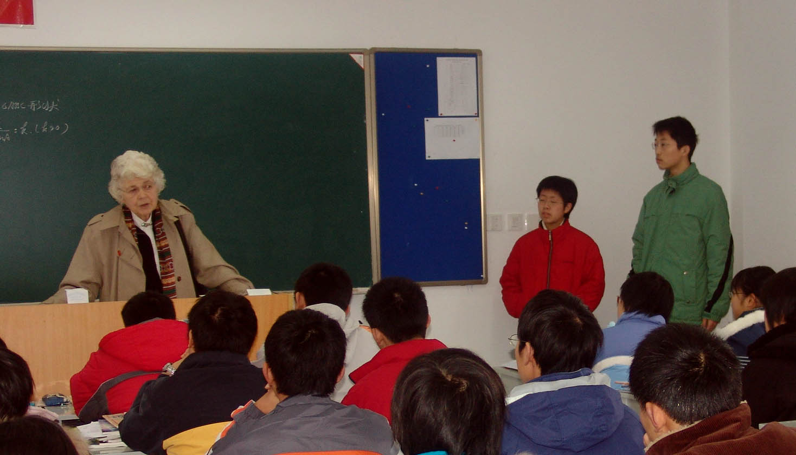

Aileen in Suzhou

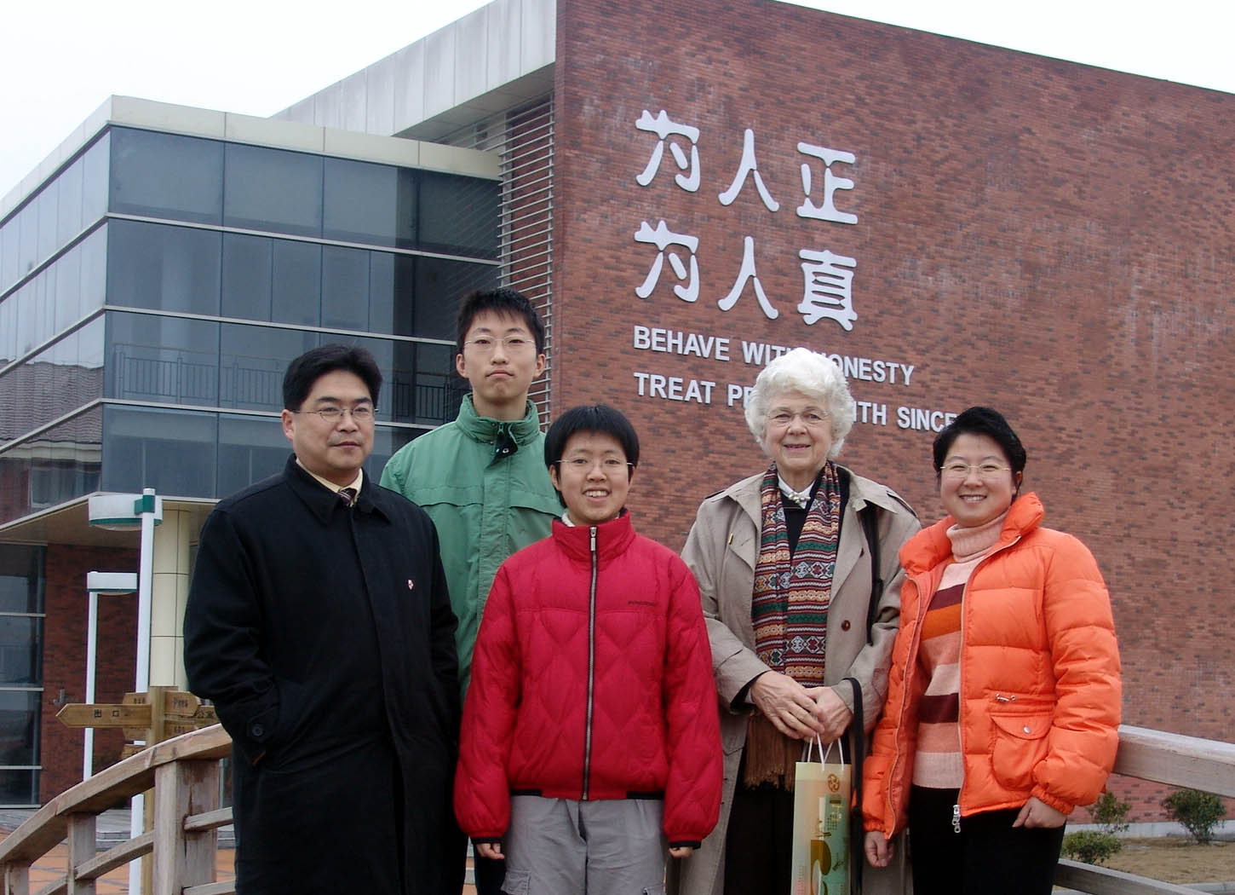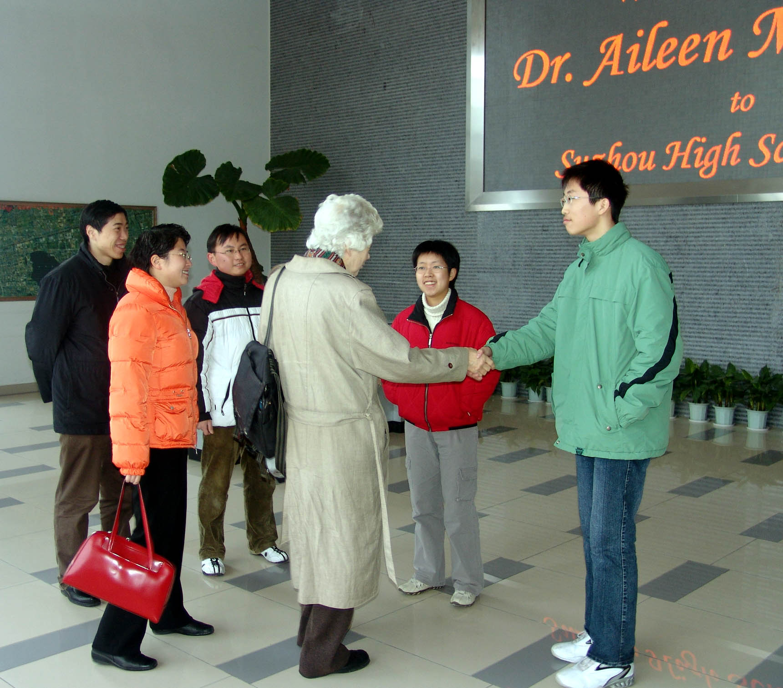

Chinese Embassy Honours Tsin Van
and Unveils Lady of Fragrance Sculpture

In celebration of the 2007 Ottawa Heritage Month, the Ambassador of the People’s Republic of China, His Excellency and Mme. Lu Shumin, hosted a reception on May 24th to honour Tsin Van, who had previously been awarded the title of “Friendship Ambassador” by the Chinese People’s Association for Friendship with Foreign Countries. The “Lady of Fragrance” created by an acclaimed modern sculptor, Master Artist Zheng Yuhe of Beijing, is a statue in bronze and gold-bronze caste presented to Tsin Van by the artist in appreciation of his life-long achievements in bringing the people of Canada and China closer together.

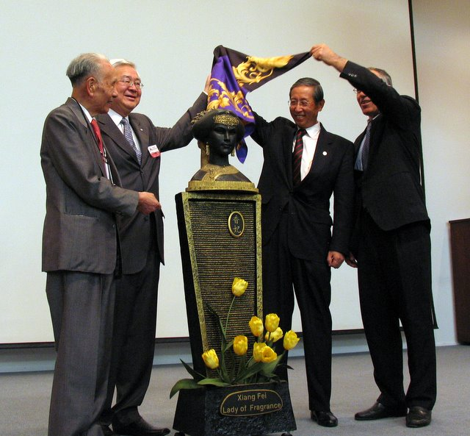

Left to right: Tsin Van, Frank Ling,
Ambassador. Lu Shumin Senator Mac Harb

Its subject is an historic figure named Xiang-fei (meaning Fragrant Concubine), who was a favorite of the Qianlong Emperor under whose long reign (1736 – 1796) the Chinese empire held powerful sway culturally and politically over the greater part of East Asia. Though facts about her are scanty, tradition holds that Xiang-fei was of Uyghur origin and was brought to the imperial court from the region of Xinjiang. The Emperor had enlarged the Chinese empire by creating the new province of Xinjiang in 1760. It was said that even more remarkable than her great beauty was the scent (xiang) that her body naturally produced. To please the homesick Xiang-fei, the Emperor had a Buddhist temple transformed into a mosque for her, and built a miniature oasis and a bazaar outside her window. Xiang-fei remained in the Emperor’s favour until her death from illness in 1788.

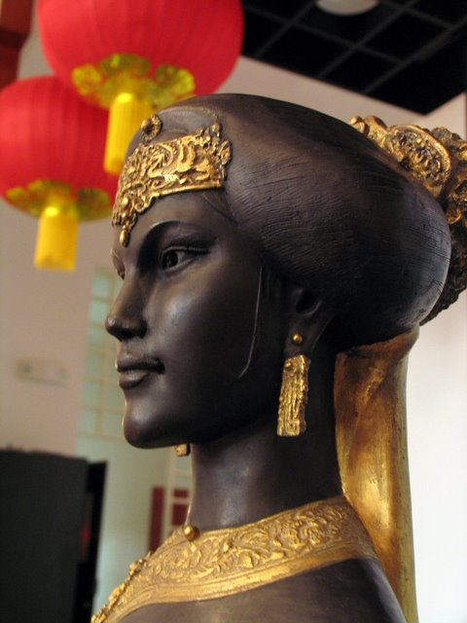

Xiang-fei’s experience at the Qianlong court served as a powerful symbol of unity between the Han-Chinese and Uyghur peoples of Muslim faith, and her story attained great popularity in 20th century China through plays, films and books.

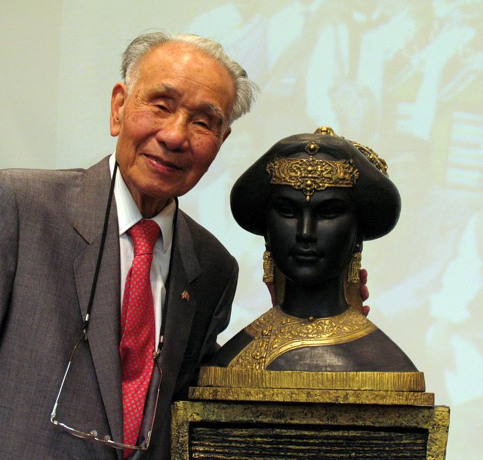

Tsin Van and friend

Cultural Counsellor Zhao Haisheng and Elizabeth Yeh, Publisher of Canada-China News and
AsiaNetwork, were principal organizers and co-emcees for this special event, while Tsin Van delivered a moving response in which he re-dedicated the evening to “friends and friendship” in the name of Xiang-fei. Many long-time friends of Tsin Van and his wife, Betty Van, attended the celebration including Senator Mac Harb, former Ottawa Mayor Jacquelin Holzman, Dr. Robert Ward who attended to his medical needs for many years, Mr. Frank Ling, President of the Ottawa Asian Heritage Month Committee, Mr. John Scholdice who created a very fine stand for Xiang-fei, Ms. Katie Ng from the Chinese community, and members of the Canada-China Friendship Society of Ottawa of which Van is a founding member. Delicious food and drinks were provided in an atmosphere of pervading warmth and friendship.

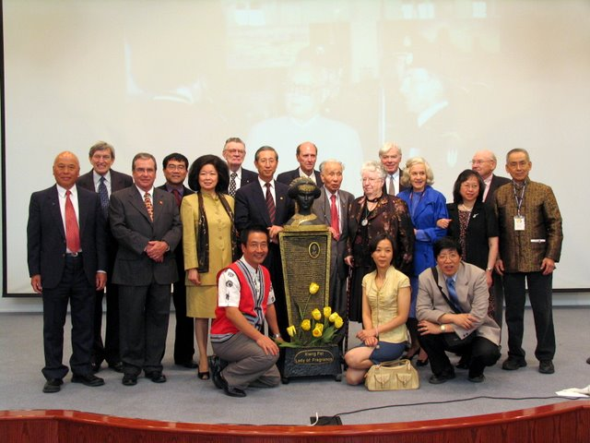

Central group flanking statue: Lolan Merklinger,
Ambassador Lu Shumin, Tsin Van, Betty Van
______________________________________________________________________________

President’s Message

Greetings to all members of the Federation chapters and to those extending the hand of friendship to the Chinese people!

The past year has seen the members of our Board attending to the goals of “fostering mutual understanding and appreciation of each other’s (Canadian and Chinese) society” – a quote from our Constitution. While our work represents a modest contribution to the broadly based activities in which Canada and China now engage, the membership of each chapter professes a genuine interest in learning about China and taking initiatives that direct assistance or encourage collaboration with specific communities in China.

Our chapters demonstrate a diversity in their programs of activities that range from extending financial assistance to a specific project in China, Canada-China university linkage projects and organizing activities for Chinese students in Canada, or simply sponsoring talks on specific topics of general interest related to China. Much credit goes to the chapter presidents whose dedication and commitment make these accomplishments possible.

December 2006 saw the passing of Molly Phillips, a much loved former president of FCCFA who was recognized by National Youxie for her pioneering contributions to friendship between Canada and China. The past year has also seen special honours conferred on Tsin Van, another former Federation president, by the Embassy of the People’s Republic of China for his extraordinary contribution to the cause of friendship. A certificate noting their works of friendship was given this month to Dr. Fleming McConnell, a former President of the Victoria chapter, and his wife, Dr. Aileen McConnell.

The year 2008 promises to be an exceptional year for China. We continue to maintain friendly communications with the CPAFFC (China National Youxie) and with other municipal and provincial associations for friendship with foreign countries. I anticipate that the new year will also bring renewed exchanges with our friends and counterpart organizations in China.

With all good wishes to you and yours.

Lolan Wang Merklinger
President

The Golden Mountain: Canada and China Interconnected
A Colloquium held at the McCord Museum, Montreal, November 1-3

I recently attended this Colloquium organized and hosted by the McCord Museum of Canadian History and Concordia University intended to explore the dynamic interactions between China and Canada from a multi-disciplinary perspective. The program included films, musical compositions, and illustrated lectures. The interconnectedness of Canada with China was explored through the perspectives of journalism, economics, early Chinese immigration, Canadian missionary endeavours, and cultural projects.

I missed the first evening’s roundtable on Canadian Journalists in China, but took in the second full-day program which was opened by McCord’s Executive Director Dr. Victoria Dickenson and Senator Vivienne Poy, followed by a session on Norman Bethune featuring a fascinating talk by Larry Hannant, a recent biographer of Bethune. The next session on Canadians in China featured veteran author Alvin Austin’s illustrated presentation on three Canadians: missionary George Leslie MacKay, Bishop White of Henan, and missionary archaeologist Dr. James Mellon Menzies. Masters student Jesse Radz’s paper on Morris Two-Gun Cohen was a valiant attempt to describe the legendary Canadian adviser to Chinese political figures from Sun Yat-sen to Chiang Kai-shek, followed by communications professor Gary Evans (Ottawa/Concordia) on past National Film Board works on China. The next session on The Chinese in Canada: Redress and Respect heard from representatives of the Chinese Canadian National Council and featured an engaging University of Toronto doctoral student Josephine Chan’s musical composition about Chinese workers and the Canadian Pacific Railroad.

Generous funding from the Social Sciences and Humanities Research Council made possible an evening presentation of an excerpt from the Opera Three Cities in the Life of Dr. Norman Bethune with commentaries by the composer Tim Brady. I learned that the City of Montreal will be celebrating the life of Norman Bethune throughout 2008 which is the 80th anniversary of Bethune’s arrival in Montreal and the 70th anniversary of his arrival in China. Organizers envision an international set of events including the participation of the cities of Montreal, Shanghai and Malaga in Spain, with a travelling photographic exhibit from the three countries, books and films on Bethune and his times in their original languages, etc.

Something to look forward to!
LWM

Local Association Reports

With this issue the FCCFA Newsletter will no longer include reports of the local associations in the body of the Newsletter. Rather we point you to the FCCFA website (www.fccfa.ca). You can find the reports of the local chapters ib the website. You can also learn more about the Federation, view past issues of the Newsletter, find the website of your own local association, etc.

The most recent meeting of the Board of Directors of the FCCFA took place on November 4. The president of each local association or society reported on their chapter’s activities. You can find their reports if you visit www.fccfa.ca

“Control” + click on www.fccfa.ca will take you to the FCCFA website. There you will find six buttons. Two buttons take you to this edition of the Newsletter, last year’s November FCCFA Newsletter; four buttons take you to the reports of the four local chapter presidents’ reports to the Board of Directors.

Calgary CCFA - Sheila Foster, President
Manitoba CCFA - Fred Drewe, President
Ottawa CCFS - Lolan Wang Merklinger, President
Victoria CCFA - Gloria MacLeod, President

*** In the News ***

Note on Exchange Rates

In July of 2005 China began to adjust its exchange rate with respect to the US dollar. For over a decade the rate had been fixed at 8.28 renminbi. Today 7.40 RMB = 1.00 USD. A year ago, the (once mighty) USD was 7.85 RMB.

One year ago, November 3 2006, the Canadian dollar (CND) was about 88 cents US; today it is $1.01 US, an appreciation of almost 15 percent
The strong Canadian dollar makes travel and shopping in China more affordable. One year ago, the Canadian dollar bought 6.93 RMB; today 1.00 CND = 7.47 RMB; that makes Chinese goods 7.2% less expensive for Canadians.

Pity the poor Americans; things in China now are 6.1% more expensive than a year ago.

MC November 23, 2007

BEIJING, China (AP) November 5, 2007-- A Chinese satellite successfully entered lunar orbit Monday, a month after rival Japan put its own probe into orbit around the moon, but Chinese officials denied there was any competition between the two nations.
Chinese space officials said the Chang'e 1 satellite, part of the country's ambitious space exploration plans, entered lunar orbit after completing a planned braking operation.

China plans to keep the Chang'e 1 -- named after a mythical Chinese goddess who flew to the moon -- there for one year, about the same length of time as Japan's probe. China launched its satellite late last month, while Japan put its satellite into space in September.

The timing of the launches raises the prospect of a space rivalry between the two Asian nations, with India possibly joining in if it carries through on a plan to send its own lunar probe into space in April.
But Long Jiang, deputy commander of spacecraft systems of China's lunar exploration program, said Beijing wanted to use its space program to work with other countries.

"We are willing to cooperate with the rest of the world to the benefit of humankind, but as to what kind of cooperation, it depends on specific circumstances," Long told a news conference.

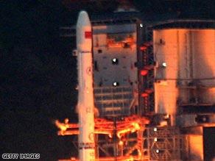

China's first lunar probe Chang'e 1

The Chang'e 1 blasted off on top of a Long March 3A rocket on October 24 from the Xichang Satellite Launch Center in Sichuan province in southwestern China. "All of the subsystems of the Chang'e 1 are in normal operation so far," said Pei Zhaoyu, spokesman for the China National Space Administration.

FCCFA Board of Directors

Lolan Wang Merklinger, Ottawa, President

Fred Drewe, Manitoba, Vice President

Sheila Foster, Calgary, Secretary

Michael Copeland, Toronto,
Treasurer, Immediate Past President

Directors

Morag MacLellan , Calgary
Gilliane LaPointe, Ottawa
Jeffery de Fourestier, Ottawa
Gloria MacLeod, Victoria

Editor of the FCCFA Newsletter

Michael Copeland

The FCCFA logo was designed by Tsin Van.

The Chinese central character is 友
(you in Pinyin, pronounced yeo, as in yeoman).
You is short for youhao; it means friendship.

Aims of the FCCFA

To promote friendship between
the people of Canada and China
by fostering mutual understanding
and appreciation of each other’s society,
their historical development and their
functioning social and economic institutions.

To promote cultural, educational,
scientific, athletic and other exchanges
between the Canadian and Chinese people

Visit our website www.fccfa.ca

Principles of the FCCFA

Any person who agrees with these aims and principles
may join a Member association of the Federation,
regardless of racial, ethnic or social origin,
or religious or political affiliation.

The Federation, and its member associations, are not political organizations, nor do they support any political movements.

The Federation and its members aim to reach out to people
of all walks of life and enlist their interest
for developing a mutually beneficial
Canada-China relationship.

The Federation and/or its member associations may organize activities for its members in order to exchange
viewpoints, discuss and study particular
questions relating to
Canada-China
relations.

The Federation and local member associations will function democratically to ensure that
all members have a voice in the affairs of the Canada-China friendship movement and to encourage the broadest and most active participation of all members in friendship activities.

