A Walk in the Clouds
Tucked away in the hills of eastern sub-Himalayas is Meghalaya, the name means “Abode of the Couds” which is exactly what the traveler feels as if they are walking on. One of the most beautiful states in India, nature has blessed her with expansive rivers, streams breaking into cascading waterfalls, twisting and turning, disappearing in the jungle, refreshing mountain air, whispering pines, exotic flora and fauna, virgin forests, high plateaus, natural caves some of which are the longest in India and remain unexplored to this day and above all with simple, honest and hospitable people. The State of Meghalaya is situated in the north east of India. It extends for about 300 kilometers in length and about 100 kilometers in breadth. It is bounded on the north and the east by Assam and on the south and west by Bangladesh. This hill state is famed as 'the Scotland of the East' and with reason because anywhere you look you see Nature in all its glory.
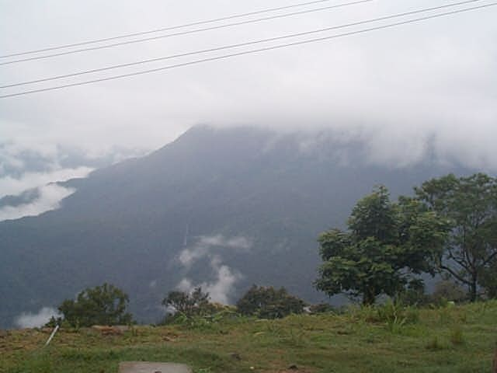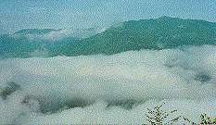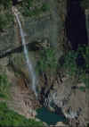
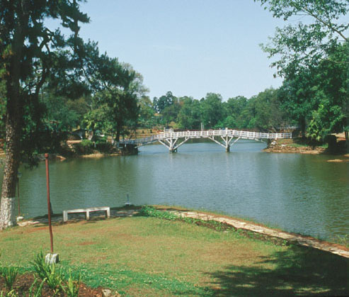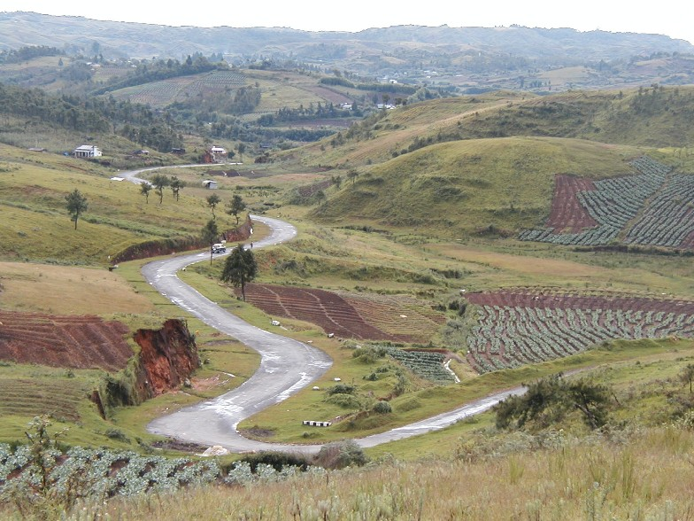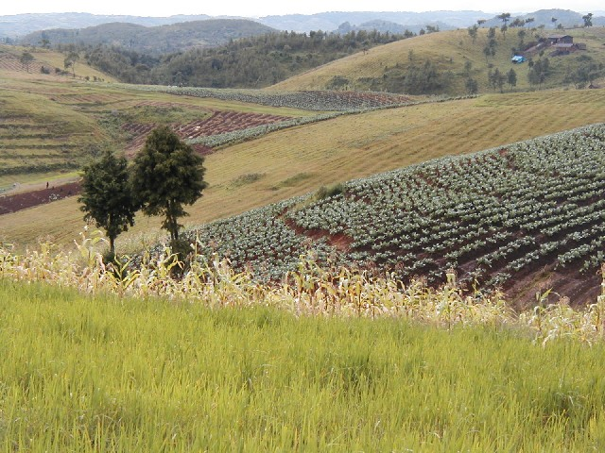

Duration : 5 Days Sightseeing Tour
Tour Description & Destinations : A Walk in the Clouds - Shillong - Cherapungee - Laitlum - Nongkrem - Smit
Day 01 : Highland Meadows Chalet - Barbecue
Meet on arrival at Shillong Airport or Guwahati Airport / Railway Station and transfer to Highland Meadows Chalet, orientation and introductory talks over a special Barbecue treat for our guests where we get to know them better.
Day 02 : Cherapungee
Leave after early breakfast for a full day trip to Cherapungee. A pleasant drive to see roaring waterfalls leaping into deep gorges, including the famous Kshaid Dain Thlen and Nohsngithiang falls. We will also visit, 12 kms from Cherrapunjee the beautiful Park 'Thangkharang'. Besides housing a bird sanctuary, the spot commands an imposing almost 180 degree view of the plains of Bangladesh and also of the imposing 1000 ft. high Kynrem falls cascading down majestically in three stages. We also visit the Noh Kalikai Falls, where a clear bubbling stream emerges from its steep mountain bed to hurl down a rocky precipice, into a deep gorge, creating a captivating view of breathtaking beauty. The day’s itinerary includes the illuminated cave of Mawsmai and Laitkynsew, where guests can trek to the Umnnoi living root bridge about 2 kms down steep cobbled stone pathway. This living root bridge measuring about 53 ft is said to be more than 100 years old constructed over a small stream and used by the villagers to reach their betelnut gardens.
Day 03 : Shillong
Full Day sight seeing of Shillong including, Ward's Lake: A century old picturesque lake also known as Polok Lake. Located in the heart of the city, with a most pleasant, winding walk-a-way all around its parameter set in cobbled sand stones, in the midst of picturesque, rolling flower beds and fairyland lighting. The lake has a striking arched bridge over it. Umiam Water Sports Complex: 16 kilometres outside of Shillong, the campus consists of a beautiful Orchid Lake Resort, the Nehru Park. Besides it offers a wide choice of exciting water sports activities with row-boats, paddle-boats, cruise-boats, sailing-boats, water-scooters, speed-boats and a floating restaurant with ferry services. Lady Hydari Park: Lady Hydari Park, stretching over a km is replete with roses and blossoms of exquisite hues and colours, is a feast to eyes. It has an excellent mini zoo cum deer park. Guests will have the option of shopping in Shillong.
Day 04 : Laitkor – Laitlum – Nongkrem – Smit – Shillong Peak
After breakfast we leave for Smit a typical Khasi village, we visit the King’s palace and see the local market place there. We then visit the village of Nongkrem and enjoy local delicacies for lunch, we then move on to Laitlum to see the majestic cliffs and the awe inspiring view. While returning to Highland Meadows we visit Shillong Peak: At 1965 metres above sea level it offers a panoramic view of the country side, and is also the highest point in the State. In the evening the city lights below appear like a star-studded abyss.
Day 05 : Shillong or Guwahati
After early breakfast return drive to Shillong or Guwahati Airport / Railway station.

We pledge 10% of the tour earnings to bring education to the not so lucky, tribal Khasi children.

Note :

1. The tour program will be adjusted depending on arrival and departure times at Shillong Airport or
Guwahati Airport / Railway Station and also on weather and road conditions.

2. We provide the option of moderate customization of the tours to suit the preference of our guests.

