DOTTY’S DIMENSIONS:
THE PREFACE
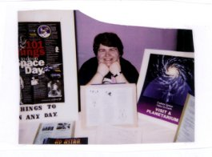

A PERZINE OF SPACE, SCIENCE FICTION, TRAVEL, AND
“OTHER THINGS” OF INTEREST TO ME.

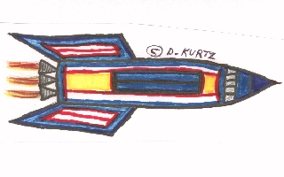

DOROTHY M. KURTZ

