DOTTY’S DIMENSIONS:
OVERSEAS
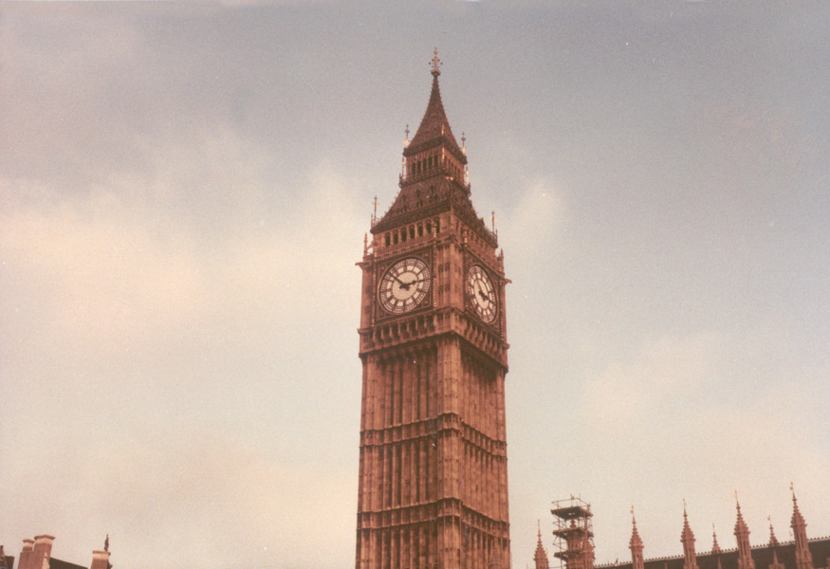

© L. Pezzuto 1982

by DOROTHY M. KURTZ

