See 64 of my favorite overseas attractions listed inside.
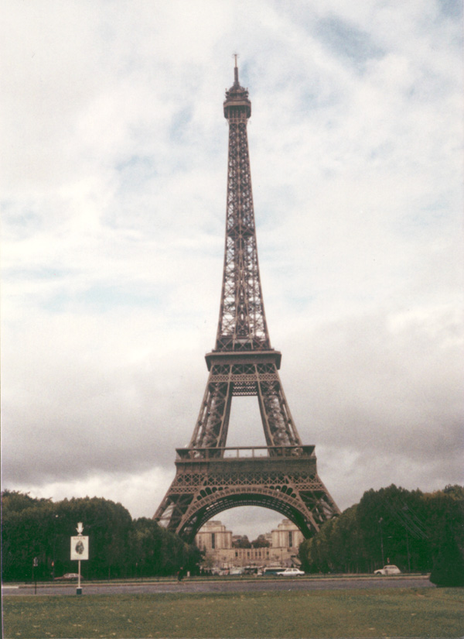

© L. Pezzuto 1985

“Imagination is more important than knowledge.”—Albert Einstein

