HAS THE BEHAVIOUR OF AGRICULTURAL MARKETS – NOTABLY FOR VEGETABLE OILS – CHANGED FOREVER?

James Fry
LMC International Ltd, Oxford, UK
[Presented at POC 2007, Kuala Lumpur, Mar 2007]

Abstract. This presentation details the links between the prices of fuel and commodities, national biofuel policies which are fast becoming a major factor in the market and finally the price outlook for oils and fats for 2007. Correlations between fuel and commodity prices are seen since 2002 when energy prices took off. The price of sugar and bioethanol as well as crude was already evident and now it has been biofuel policies in the EU and US which hold the key to the oils:fuel link. Biofuel incentives in the EU in 2010 mean that there will be a narrow range of Malaysian CPO prices (below or above US$550 vs US$40/bbl) at which 5-6 million tonnes of biodiesel demand will remain or vanish, in price-competitive terms. US biofuel policy is shifting emphasis on corn will tighten soy supply, but the impact will only be felt after 2007 when present excess supply is exhausted. The outlook for CPO prices will be forecast according to the inverse relationship between Malaysian palm oil stocks and CPO prices. CPO futures prices will move up to the M$2,000 – M$2,200 range, and average M$2,060 for 2007. If stocks end the year 120,000 tonnes below or above the base figure of 1.5 million tonnes, prices will average M$2,240 or MR$1,950 respectively

Prices of Fuel and Commodities – Spot on Commodity!
The links between product and mineral oil prices do not necessarily behave the way that one would expect. In the next diagrams below the monthly price fluctuations for a range of commodities with the fluctuations for Brent North Sea crude mineral oil. Later we would see how palm oil and palm kernel oil (PKO) fit into the general picture.

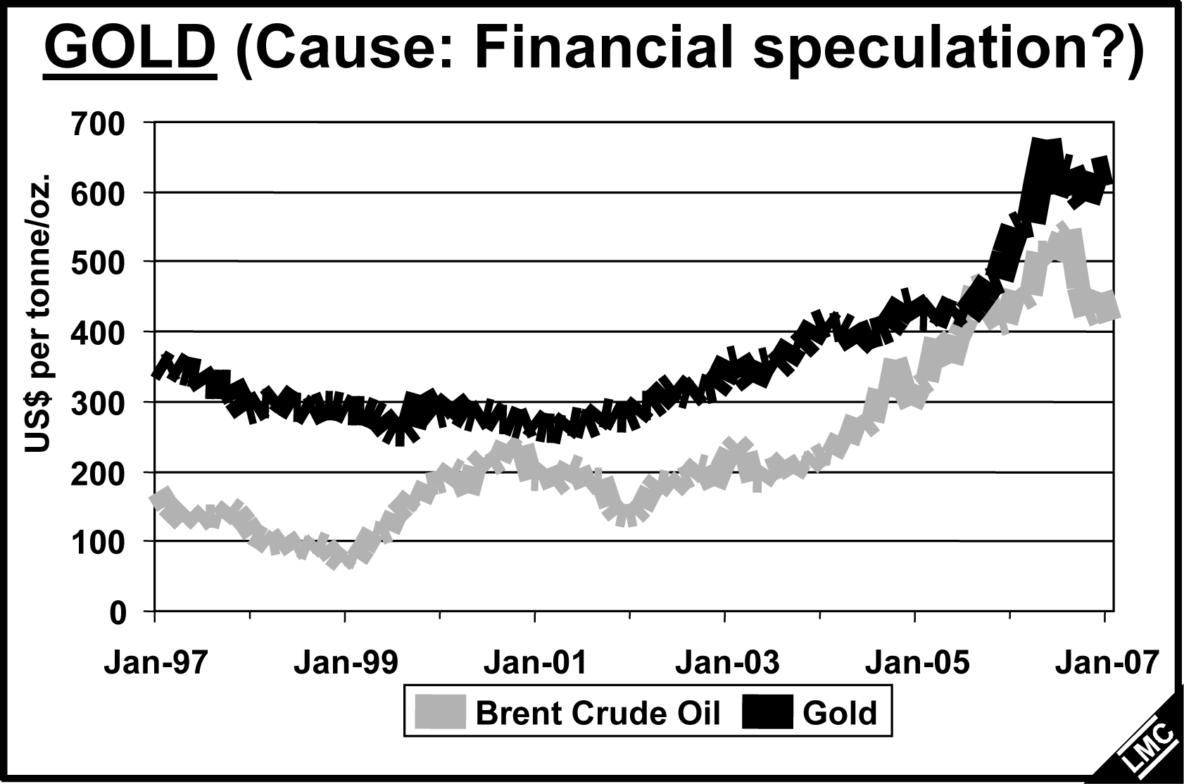
Fig. 1 is for gold and there is a very close correlation, probably caused by financial speculation of inflationary trends. Fig. 2 is a surprise as shown, the correlation becomes better in the later period. The commodity is sugar and this is due to Brazil’s use of bioethanol. Over the period shown there is general correlation of the commodity with mineral oil. Sugar prices follow those of energy and fluctuations trend together due to the switching uses for food and biofuel so that the sugar commodity is now following the the energy market. Fig. 3 is another surprise as one would not expect the prices of natural rubber to be so strongly correlated with energy prices. It is possible that the reason may be due to synthetic rubber prices but then we would not expect that there will be significant substitution in the short run. The three examples (gold, sugar and natural rubber) show correlation with energy prices with the commodity sugar most likely due to its use as bioethanol.

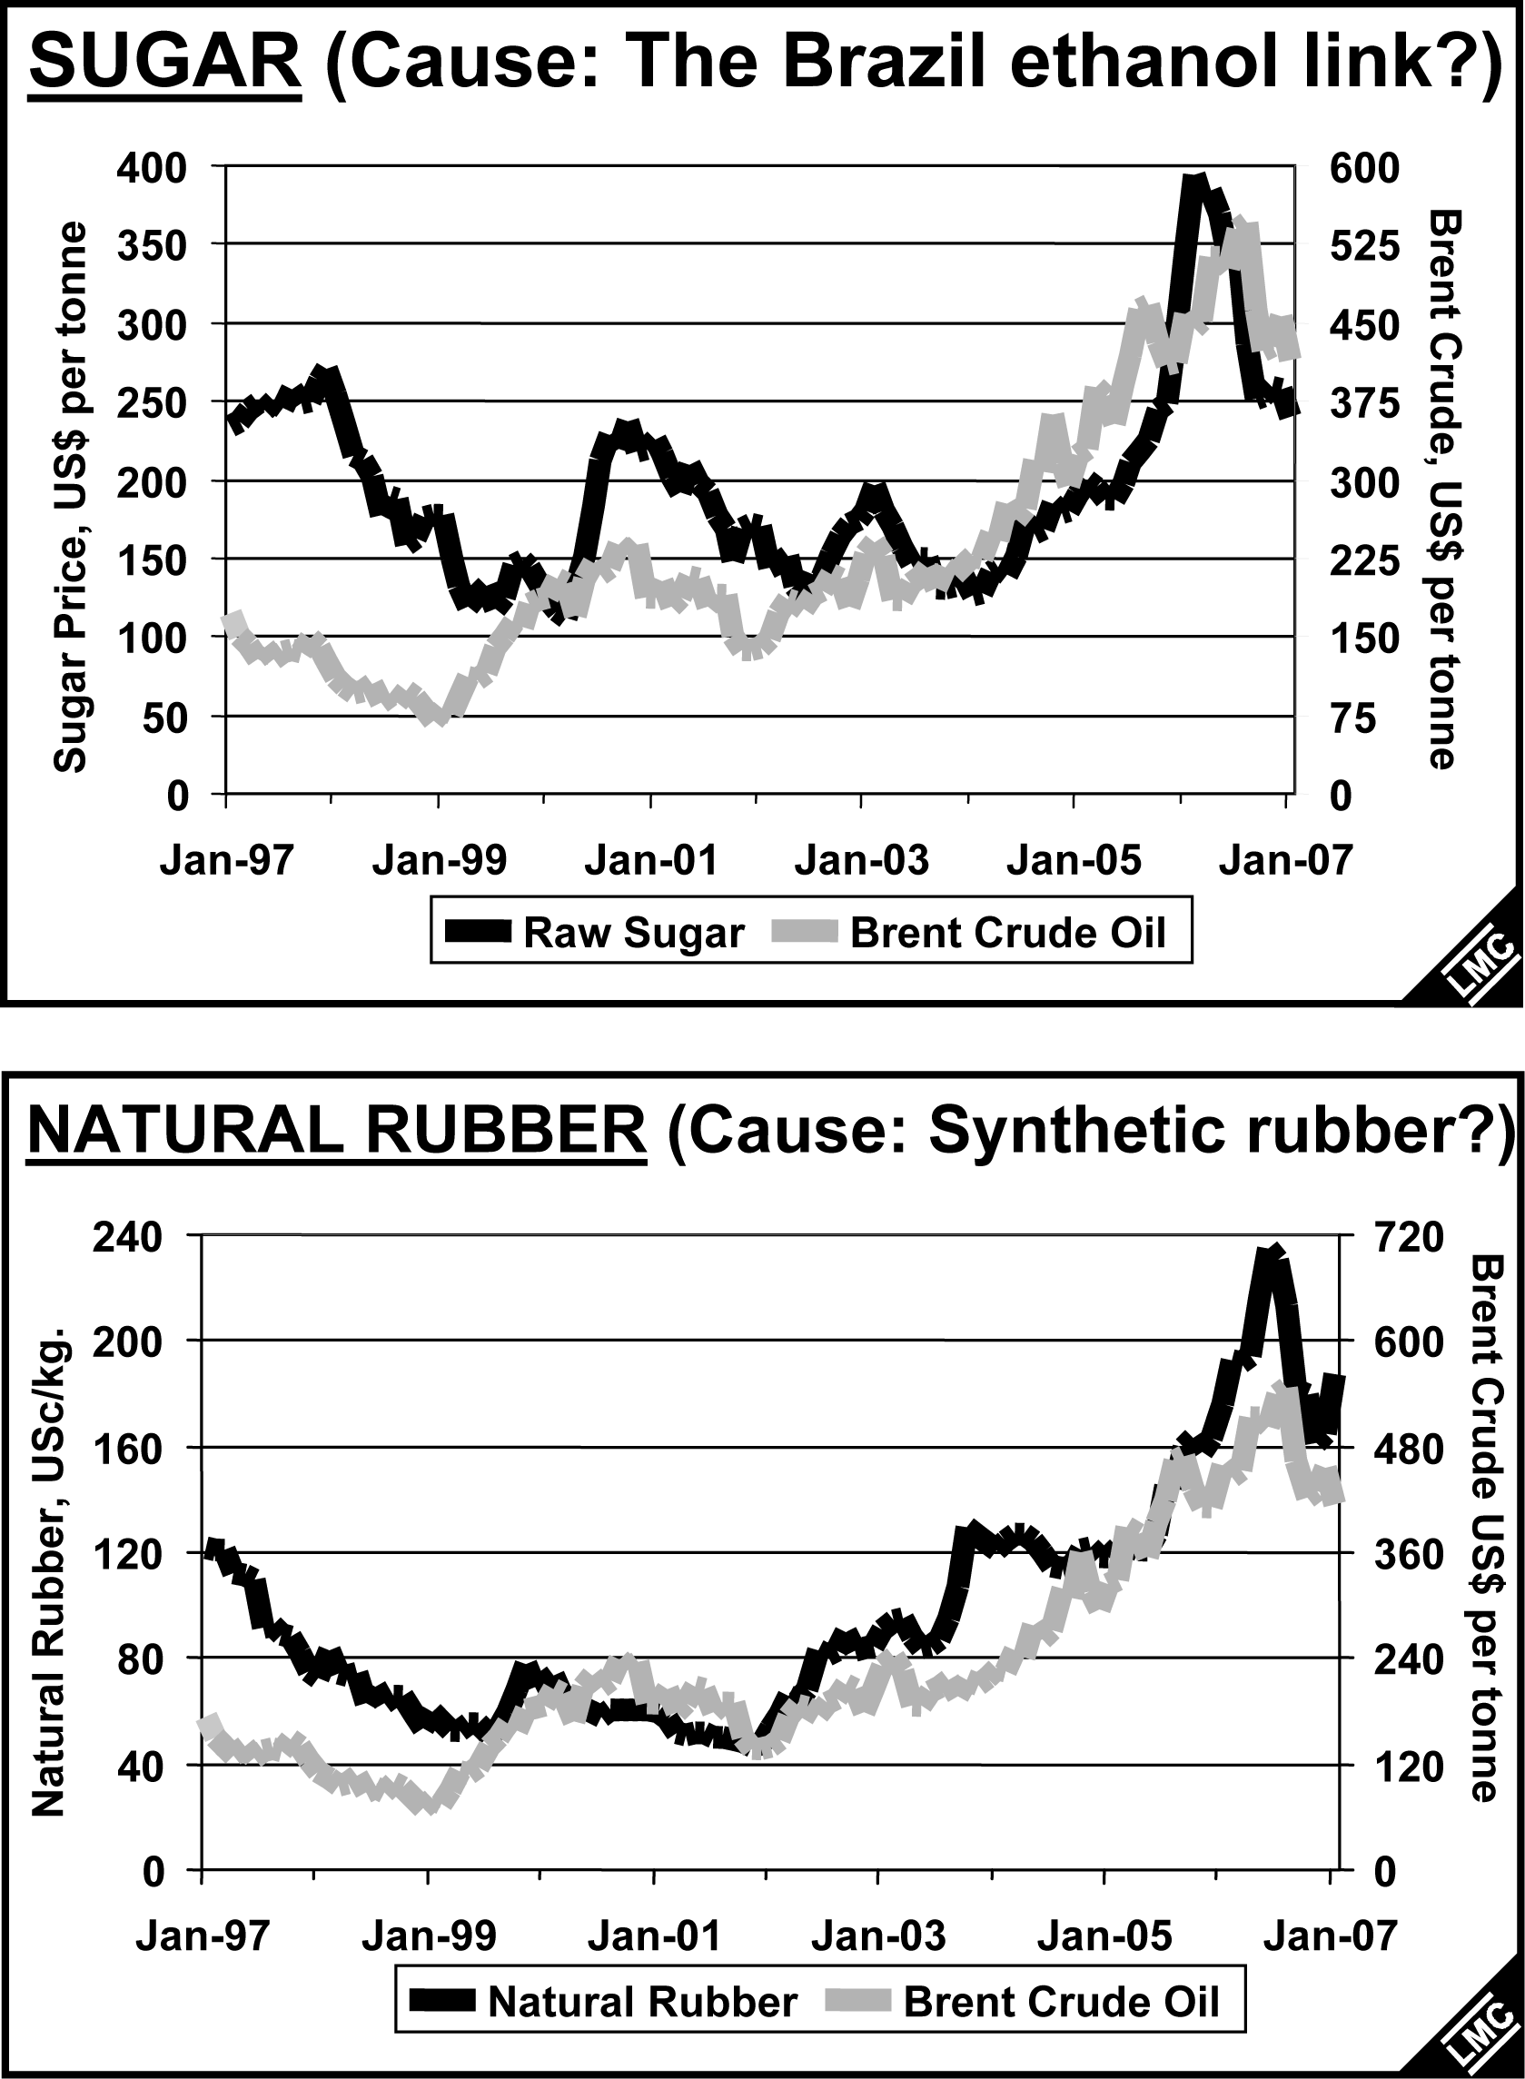

Fig. 4 illustrates the rather dreadful (almost negative in the first part) correlation of maize/energy prices despite the use of maize for bioethanol (energy) but then it is only recently (2006) that crop is being significantly used for biofuel. US corn-based biofuel has lately exceeded that of Brazil’s sugar-based bioethanol but even then the correlation is not yet seen to be positive.
Fig. 5 shows correlations of some vegetable oils (palm, rapeseed and PKO) with crude oil. Among these oils rapeseed is included because of its widespread use in Europe. Although better than maize (especially for rapeseed), the vegetable oil prices do not show any significant correlation with crude oil prices. As can be more obviously seen in rapeseed’s correlation after the period 2002, it may be useful to be more scientifically work out correlation coefficients for the vegetable oils and other commodities after 2002 when crude oil began to trend upwards.

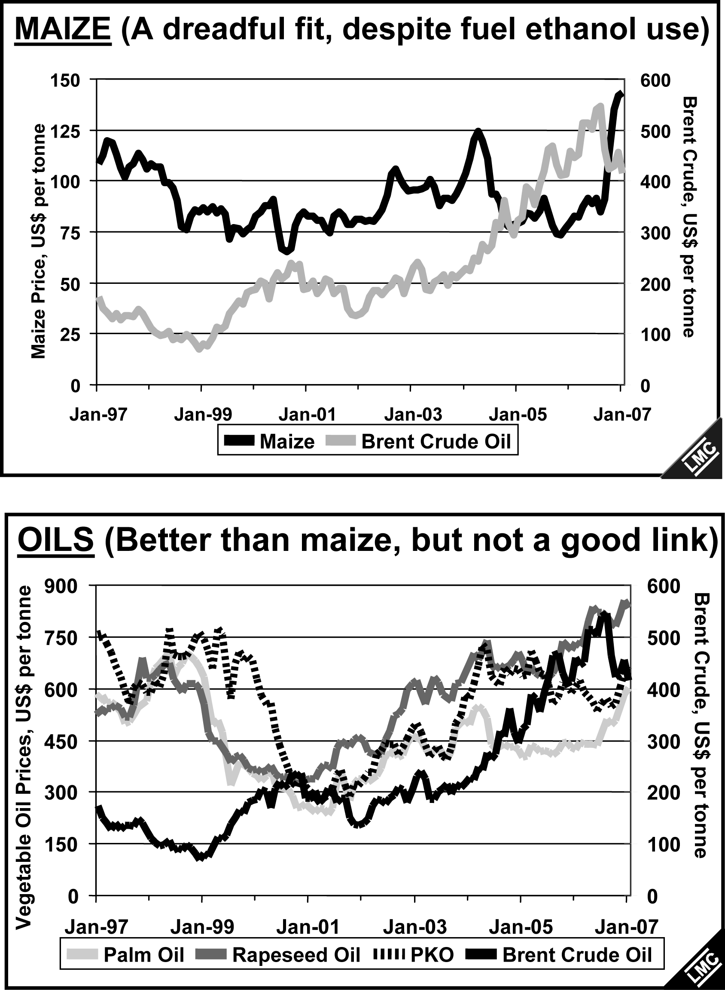

Correlations between Monthly Fuel and Commodity Prices since 2002, when Energy Prices Took Off
The recent surge in fuel prices started to get under way in 2002. Since then, with maize the main exception, many commodity prices have been reasonably closely correlated with Brent crude prices. When the monthly price correlations are calculated separately for the years from 2002 to 2004 and from 2004 to 2006 (the latter period being the one that saw the main energy price swings), the picture (Fig. 6) changes considerably. Since fuel prices started to surge in 2002, the prices of a few commodities – the unlikely trio of gold, natural rubber and sugar – have been closely correlated with fuel prices. A puzzling feature of the comparison of the correlations calculated for 2002-2004 and 2004-2006 was that the links were generally much worse in the second period, which was when fuel prices reached their highest levels.

Will Brazil Show the Way for Oils? Brazil has the world’s longest running biofuel programme, making ethanol from sugar cane. The government use to fiz local fuel ethanol and sugar prices, but he market has been increasingly liberalised, especially since 1906. The result has been that one nation (Brazil) has effectively arbitraged between the world sugar and fuel markets, switching sugar cane juice from the less profitable to more profitable product, and linking the two sets of prices.

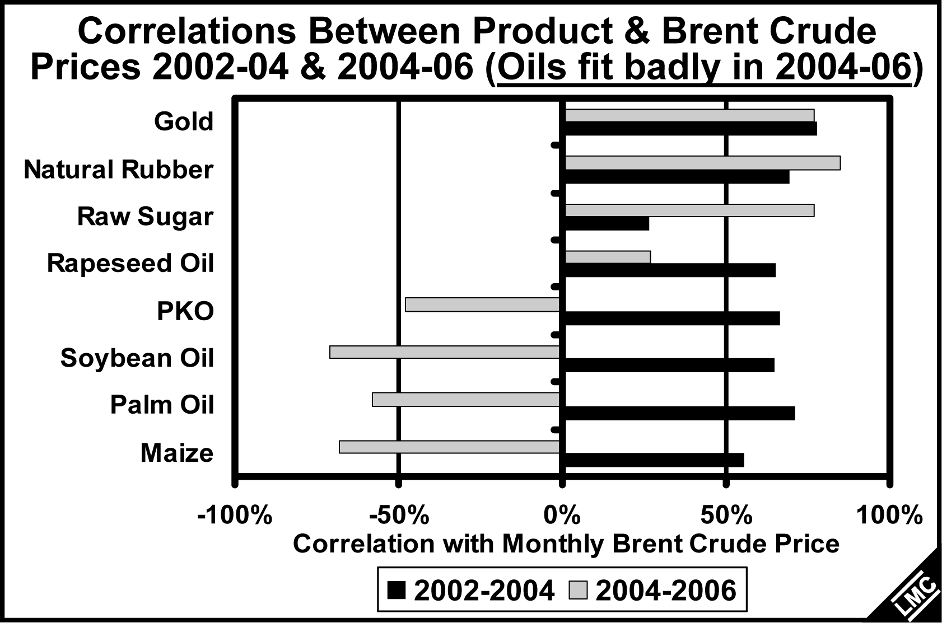

When will Vegetable Oils follow Sugar’s Close Link with Fuel Prices?

Fig. 7 reexamines the correlations of world sugar, Brazilian ethanol and Brent crude prices and the close link of sugar with ethanol is noted. The switch-over to the use of bioethanol is most evident when prices of sugar falls while crude oil rises so that bioethanol becomes relatively price competitive. Apart from sugar, from Fig. 6 there is as yet no evidence that vegetable oils have yet joined sugar as products tied to fuel prices except for rapeseed because of its widespread use as biodiesel in Europe.

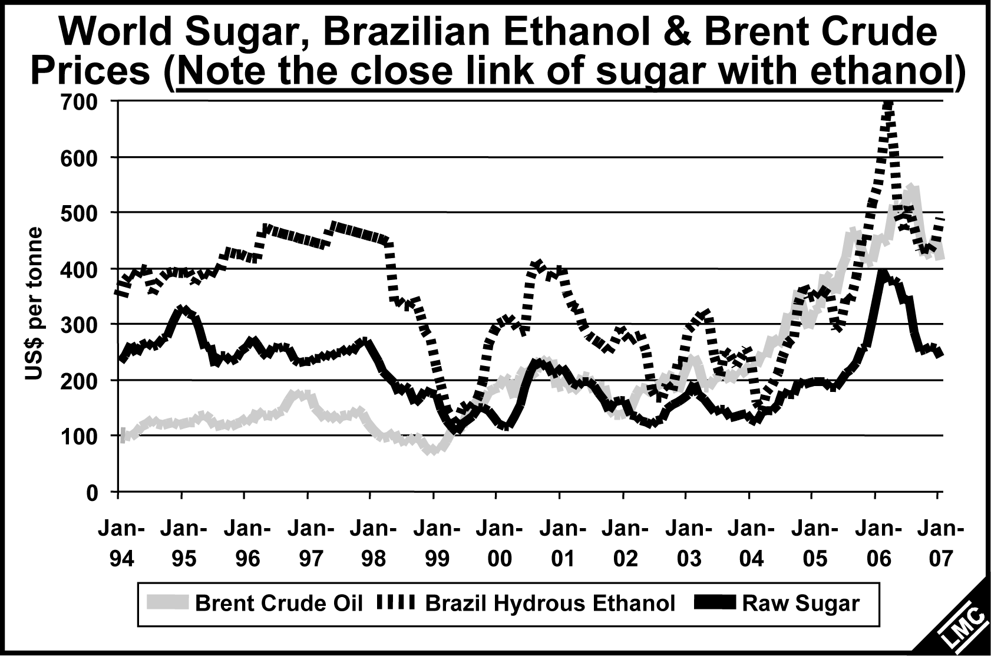

Biofuel Policies in the EU and US Hold the Key to the Oils:Fuel Link

In the case of Brazil, governmental policy is fairly even-handed between sugar and fuel. In the world of biodiesel, the array of policies is vast: targets, tax incentives, penalties if targets are not achieved and mandates are all used. Below we have to translate US and EU inducements for biodiesel use into break-even CPO prices for biodiesel output vis-à-vis Brent crude.

EU Trade-Offs: CPO vs Biodiesel. The US palm biodiesel trade-off (fuel price vs CPO prices) is simpler as we have Malaysian CPO price of US$550 competitive with fuel price of US$63 per barrel. In the EU several factors need to be taken into account and Fig. 8 illustrates the combined effect of processing costs with the complex web of biodiesel targets, biodiesel mandates, import tariffs, biodiesel tax incentives, and penalties (if biodiesel targets are not achieved). To determine break-even CPO prices for biodiesel in every single EU-25 member state vis-à-vis Brent crude (for diesel), taking US$60 and US$30/barrel as illustrations, in 2010.

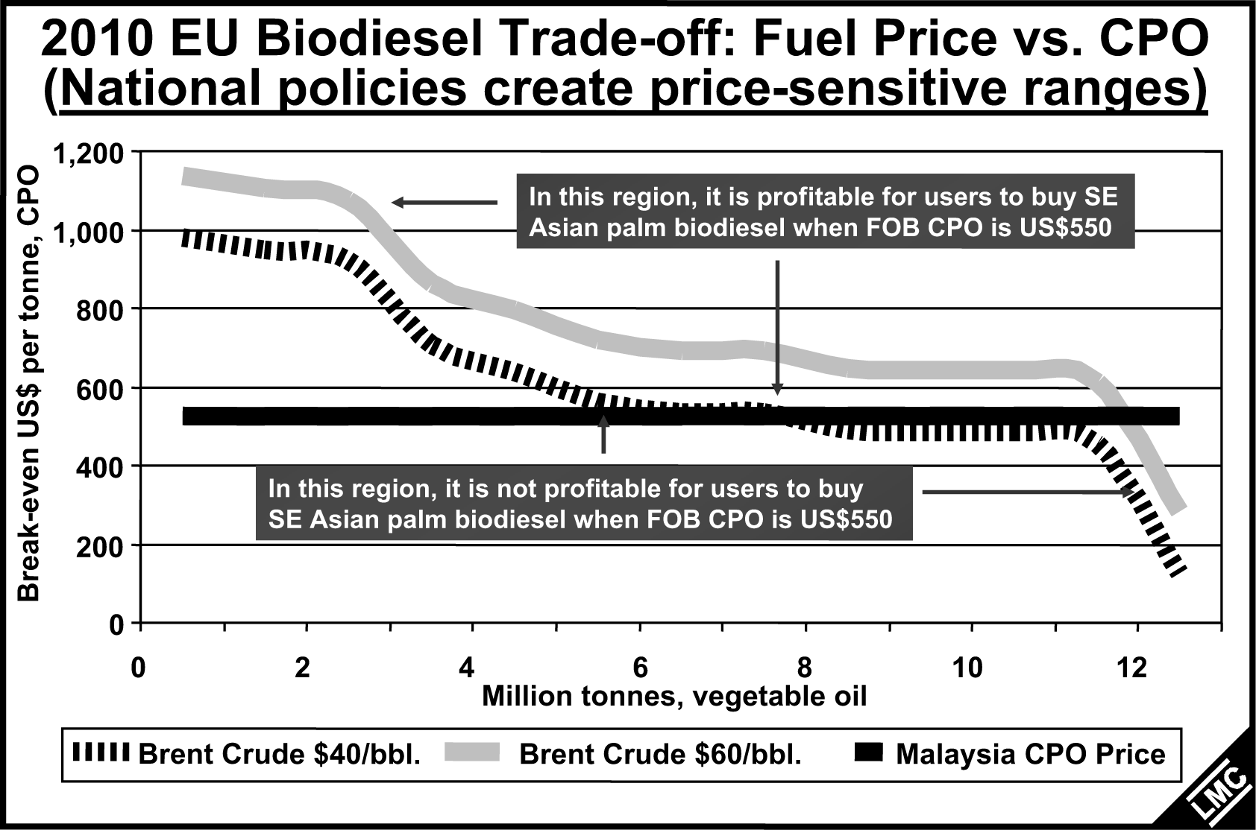

2010 EU Biodiesel Trade-off: Fuel Price vs CPO. Considering that we need processing costs, shipping costs and perhaps other incentives, etc, in EU member states and further considering US$60 and 40/barrel for crude oil as examples, what will be the disparity between CPO price in Malaysia and the value of biodiesel in Europe? We can arrive at Figs. 8 & 9 where national policies create price-sensitive ranges for profitability or otherwise. It is profitable for users to buy palm biodiesel when FOB CPO price is US$550 when crude is between US$40-60/barrel. If fossil diesel remains at these levels, it is of interest for countries and producers (especially with high taxes of fossil oil) to realise that CPO price is at parity (on the left side of the graph) and up to 12 million tonnes (inclusive of other edible oils) can be sold for this purpose.

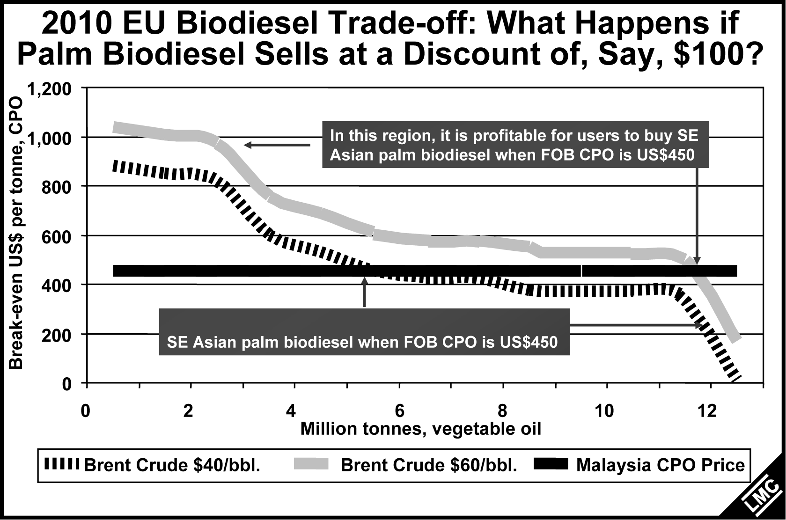

In a more realistic situation, however, palm diesel may only be sold at a discount (as is the realistic situation today), of say US$100, then it will only be profitable for users to buy CPO at US$460/tonne. Only about 5.5 million tonnes of biodiesel can be sold competitively against petroleum diesel. Note that the demand for several million tonnes of biodiesel is determined when the price of biodiesel is hovering around the US$460/tonne and any upward movement of this price level will cause the demand to disappear.

EU Tradeoffs: Implications for CPO. Biofuel incentives in the EU in 2010 mean that there will be a narrow range of Malaysian CPO prices – near US550/tonne at US40/bbl for crude – at which 5-6 million tonnes of biodiesel demand will vanish, if biodiesel is to be competitive with fossil diesel and Malaysian processors are to cover their processing and sea freight costs and EU import tariffs. Any discounts for palm methyl ester on other sources will lower this price-sensitive range accordingly. This very large potential price-sensitive swing in demand will inevitably tie CPO, and other vegetable oil, prices much more closely to fossil oil prices.

The Balance Between Fuel Ethanol and Biodiesel Can Cause Imbalances. There is another factor at work: competition between bioethanol and biodiesel as biofuels. The US favours bioethanol over biodiesel as few of their cars are powered by diesel but the country uses 44% the world’s petrol. The need for a substitute fuel has resulting US policy of promoting corn for bioethanol production and this has affected local price of corn vs soybean and farmers’ choice of crop. US official forecasts illustrate the implications of this policy choice for soybean output (Figs. 10 and 11).
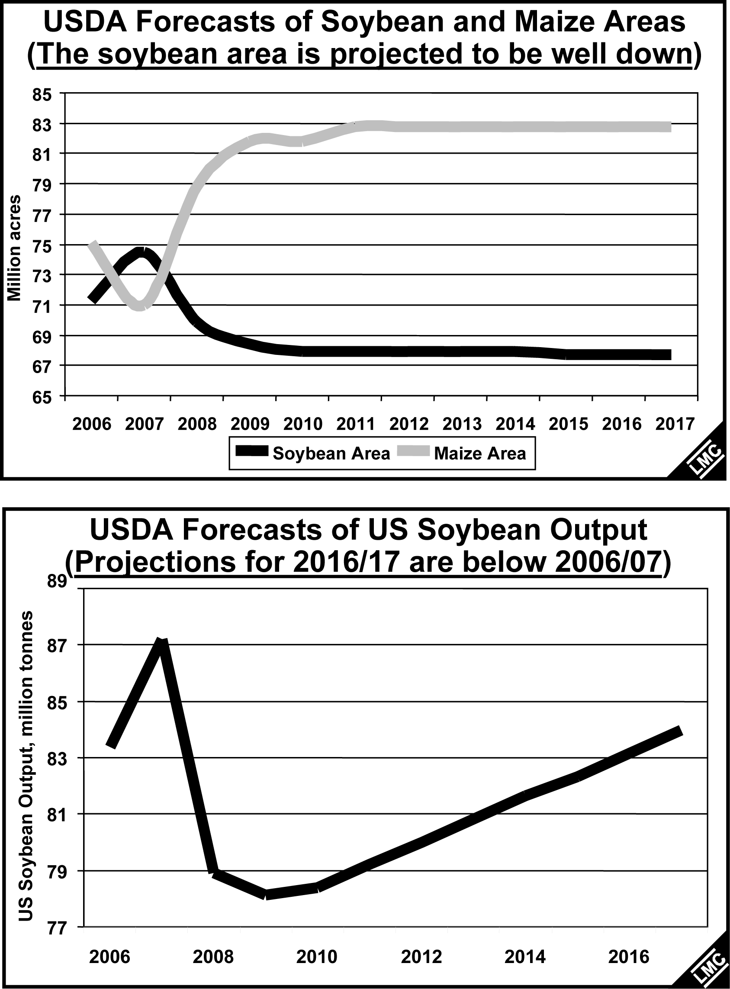

US Biofuel Policy Tightens Soy Supply.US policy is generating shocks to the world oilseed market, tightening soybean supply, but its impact is not confined to the US alone. China is shifting land from soybeans to maize. On the other hand, rapeseed areas are on the rise in response to biodiesel demand. In Ukraine and Russia, the switch is partly away from sunflower, with relatively little consequent net effect upon oil output. In Europe and Canada, rapeseed plantings will expand significantly in 2007/08, but some major EU rapeseed regions are now at the upper limit of their rapeseed areas within the recommneded crop rotations where rapeseed is planted no more than one year in four.

What This Means for the Global Vegetable Oil Supply-Demand Balance and Prices
Due to a high 2004/05 soybean crop, the world is still not short of potential oil (in oilseed stocks). However, global oil demand is growing slightly faster than its output for the second year running (Figs. 12 and 13). Looking ahead to 2007/08, we should see the consequences of soybean areas being switched to maize, led by the US, and this will counterbalance the expansion in rapeseed plantings. Meanwhile, biodiesel capacities are surging ahead, boosting oil demand and offsetting lower direct use for burning, notably in the U but also in various Asian countries.

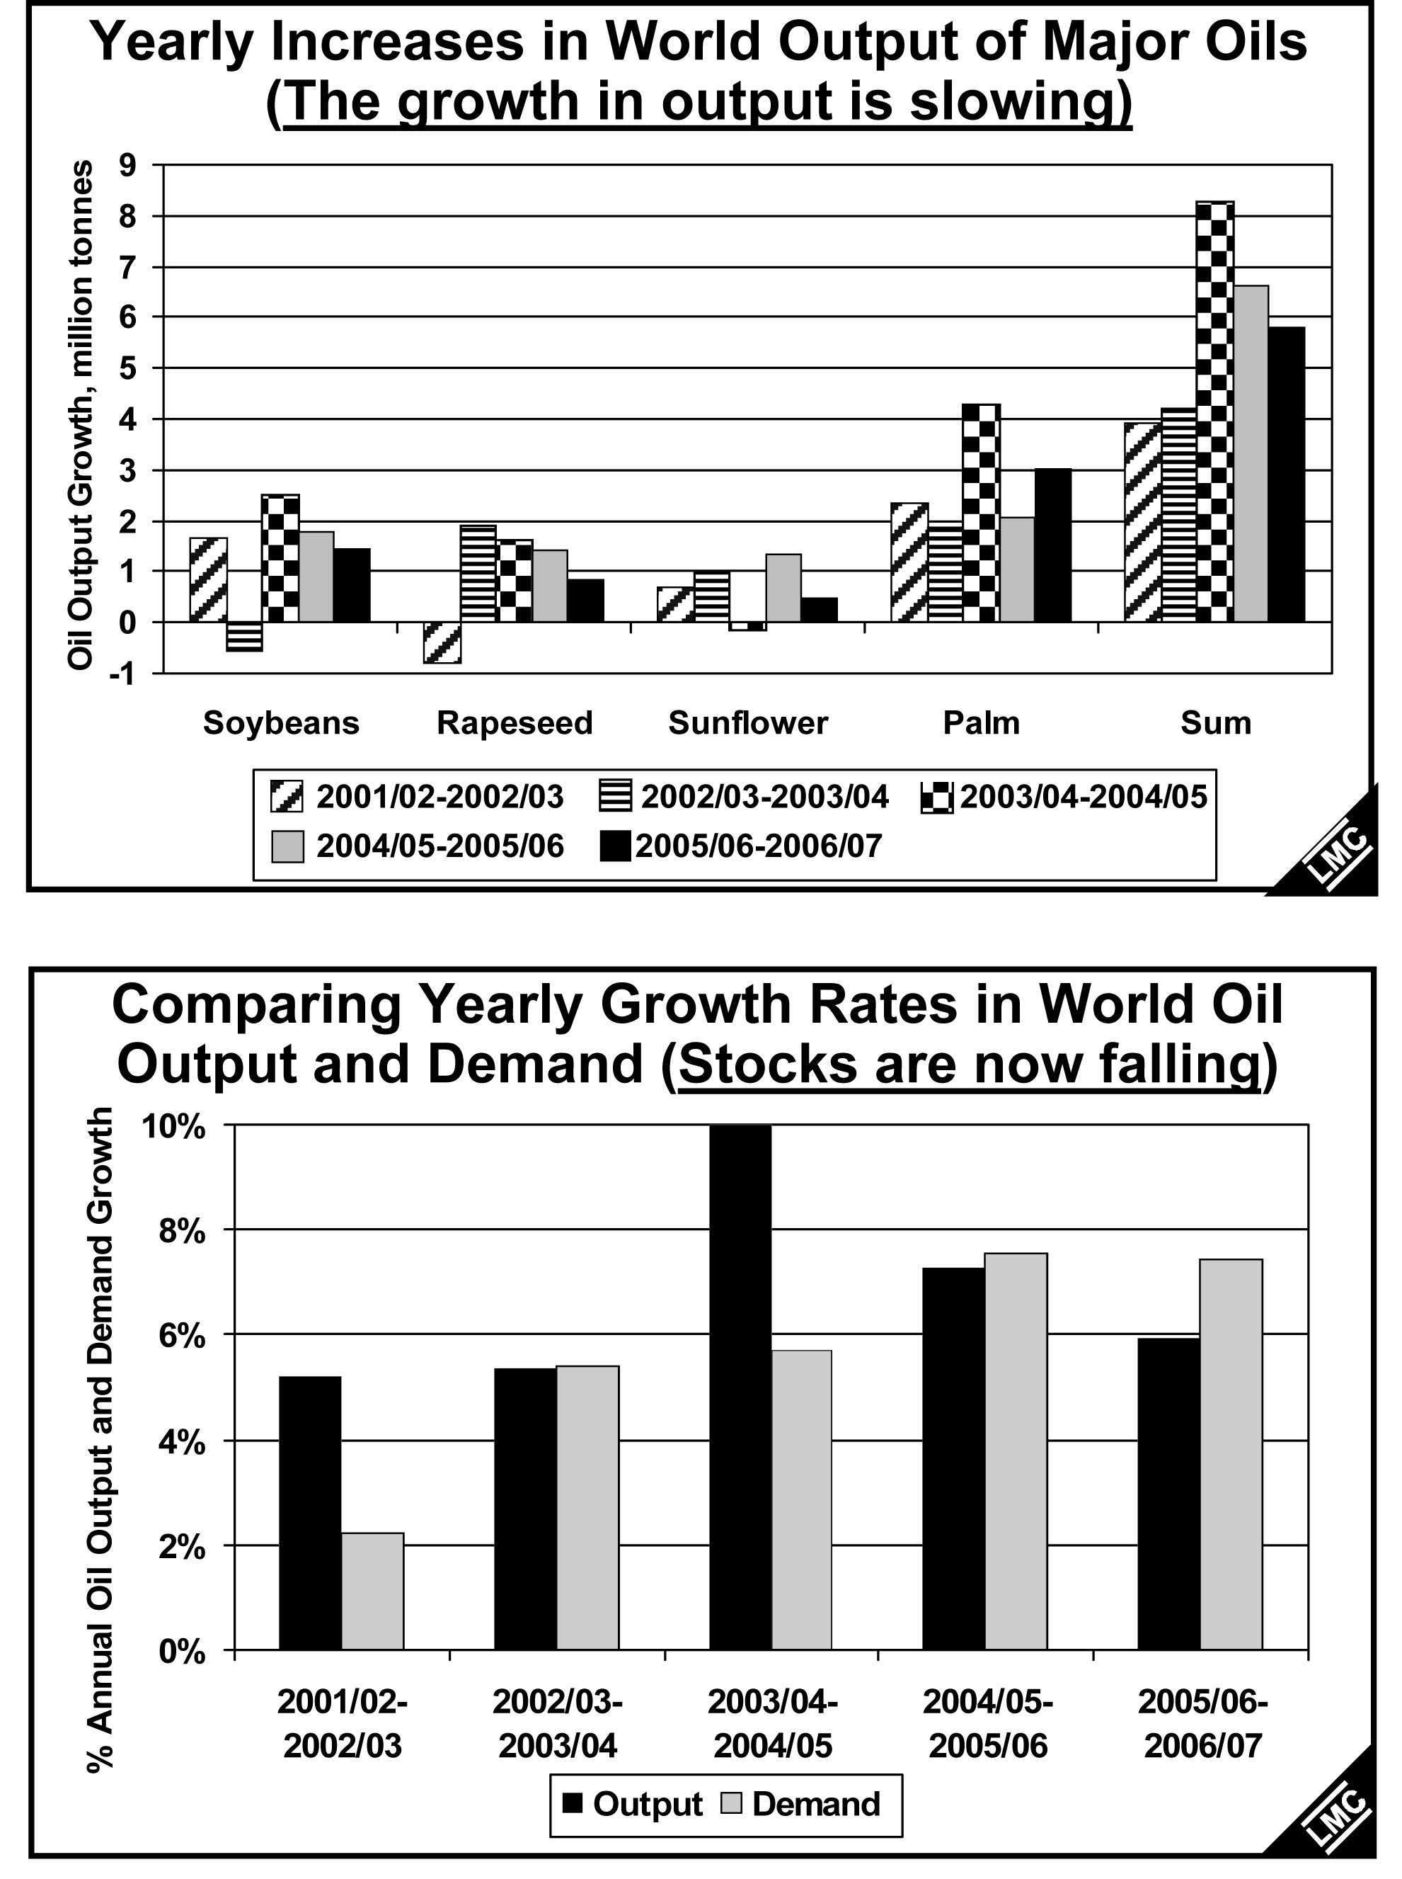

The Outlook for CPO Prices. Oil stocks are the key determinant of world CPO prices, since only palm oil is produced directly as oil, rather than as oil-in-seed – unlike annual seeds. The inverse relationship between Malaysian palm oil stocks and CPO prices still holds true (Fig. 14). The forecasts that follow reveal the sensitivity of the 2007 price outlook to Malaysian stocks. Besides the “base case”, I shall show how Malaysian stocks either 100,000 tonnes higher or lower than in the base case by October would affect the price forecasts. Year-on-year changes in Malaysian stocks vs changes in CPO futures (Fig. 15). Implications of forecasts for MPOB stocks are shown in Fig. 16 and likewise implications of the forecasts for Bursa Malaysia Prices in Fig. 17.

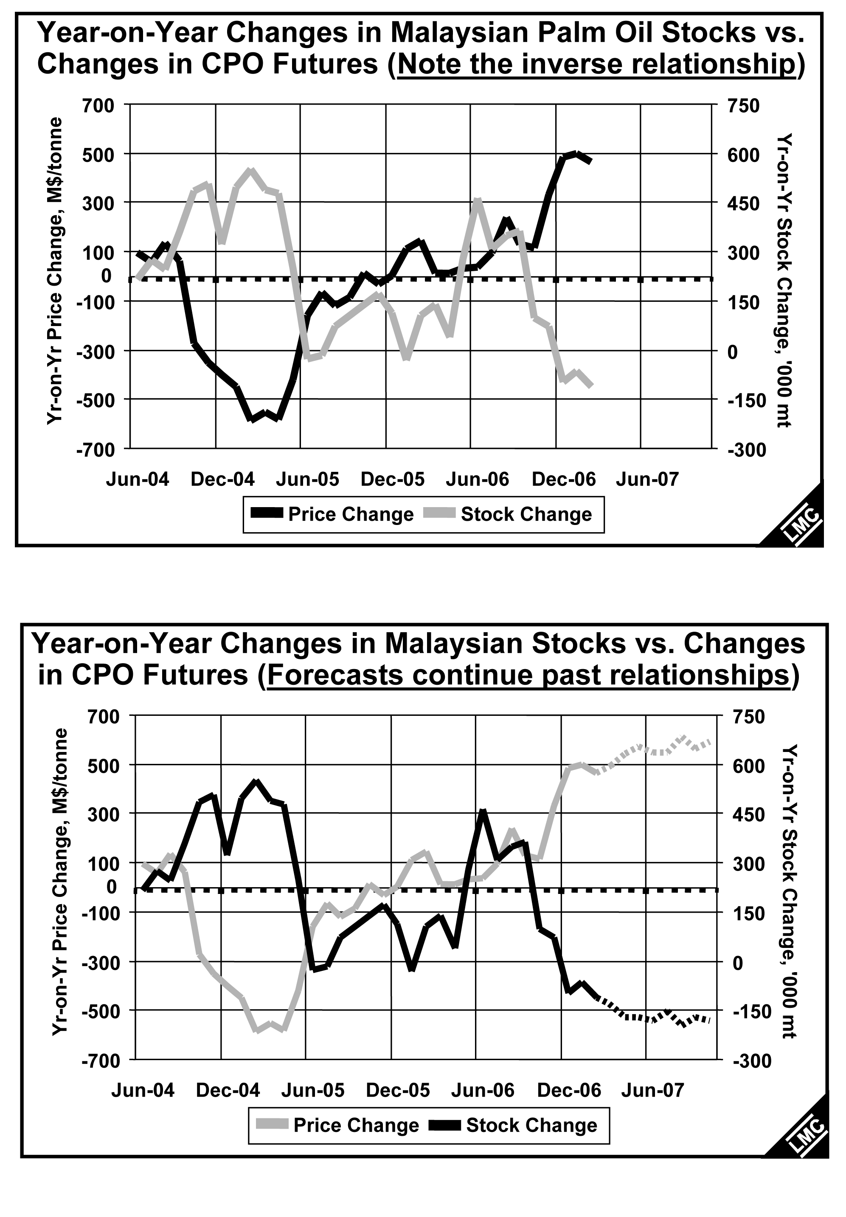

Outlook for Malaysian CPO Prices. In the past year, some of the sparkle has gone from the biofuel sector. Biodiesel capacities are coming on stream, but governments are fickle an some are shifting gear, e.g., Germany’s tax incentives are less generous than they were. Also, European policymakers are giving mixed signals about using oils as fuel; they object to incentives for direct burning, but are glad to subsidise biodiesel use! Meanwhile, soybeans in the US are losing land on a large scale to grains. This points to lower oil stocks, but as we have seen recently biofuel use is price-sensitive, and this will limit any CPO price rise.

Malaysian CPO Price Forecasts. Our base case forecasts imply that Malaysian CPO futures prices will move up to the M$2,000 – M$2,200 range, and average M$2,060 for 2007 (Figs 16 and 17). If stocks end the year 1200,000 tonnes below our base figure of 1.5 million tonnes, prices will average M$2,240. If stocks end 120,000 tonnes above the base case, prices average M$1,975. The laurics will be led the CPO price (but it was interesting to see that PKO prices follow Brent crude more closely than CPO). For 2007, our average PKO price forecast is M$2,275.
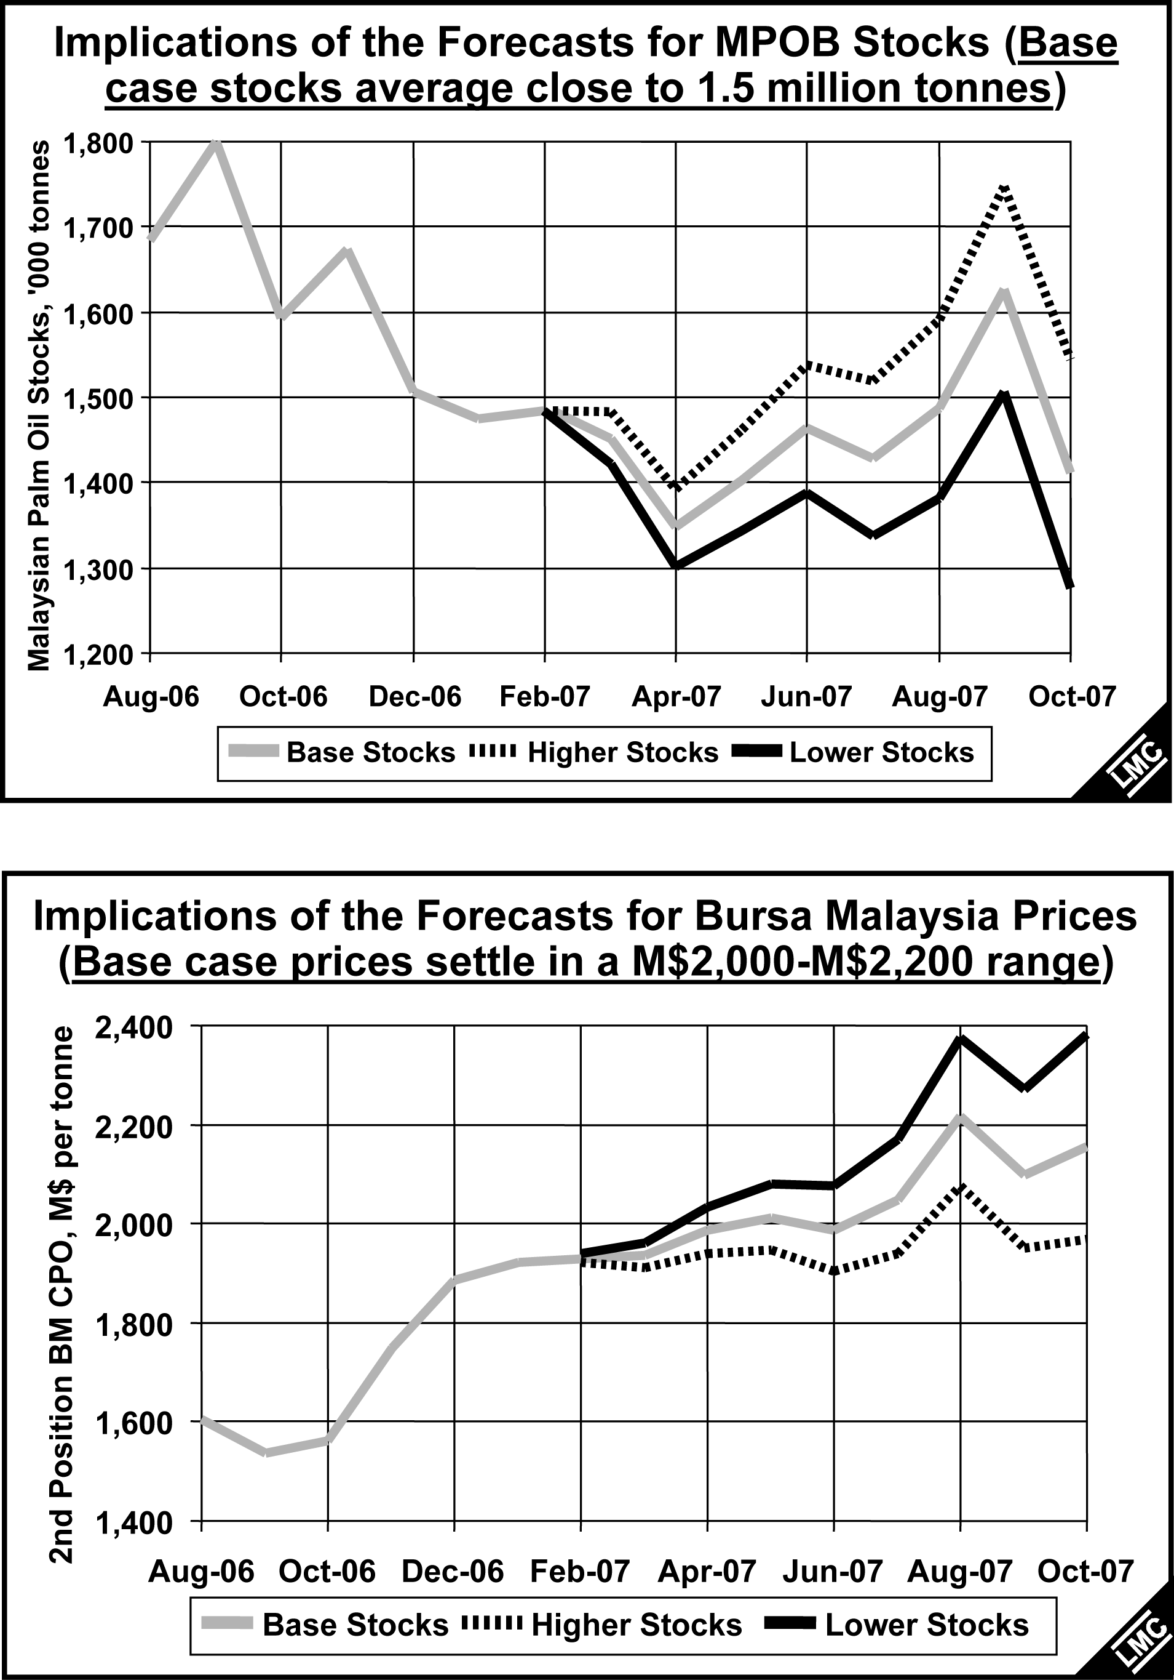

Has Price Behaviour Changed Forever? Yes, price behaviour has changed forever. A new influence, energy prices, is at work, which will not vanish and its impact extends to nearly all crops. However, we have seen in the past year that many governments will not give unlimited support to the use of biofuels, without regard to the cost. Thus, although fuel and palm oil prices will be increasingly closely linked in the future, we expect that concerns about food supplies and prices will become of growing political concern(witness the recent riots about tortilla prices rises in Mexico). Governments may be expected to use their powers to avoid giving biofuels too big a role in food markets.

